**NAM – Monitoring**

**DataDog**

Version: 1.0

Last update: 14/04/2020

**Revision History**

|  |  |  |  |
| --- | --- | --- | --- |
| **Version** | **Author** | **Date** | **Change Description** |
| **1.0** | Salik Shahid | 14/04/2020 | Initial Version |
|  |  |  |  |
|  |  |  |  |
|  |  |  |  |
|  |  |  |  |
|  |  |  |  |
|  |  |  |  |
|  |  |  |  |
|  |  |  |  |
|  |  |  |  |

Table of Contents

1. Introduction 4

1.1 Purpose of the Document 4

1.2 Assumptions and Constraints 4

1.3 About NAM: 4

1.4 About Datadog: 4

2. Datadog Anatomies Used in NAM Monitoring: 4

2.1 Datadog Agent: 4

2.2 Custom Metrics: 5

2.3 Tags: 5

2.4 Common Paths: 6

2.5 Common Commands: 6

3 Datadog Parameters Set On NAM Application Servers: 6

3.1 TWO and PGS Application Server 6

3.2 TWCMS and TWRBP Application Server 6

3.3 TWINAM Application Server 6

3.4 FIMI Application Server 6

3.5 IRIS Application Server 7

3.6 TWONAM DB NODES 7

3.7 CMSINAM DB 7

4 Alerts 8

4.1 Application Process Monitor: 8

4.2 Log Monitor: 14

4.3 File Monitor 19

4.4 MV Monitor 26

5. NAM Dashboard: 32

5.1 Application process monitor: 32

5.2 Log monitor: 33

5.3 File monitor: 34

5.4 BAU TASK Monitor 35

5.5 NAM CARD STATS 35

5.6 UNIT STATE MONITOR 36

5.7 NYCE TRAFFIC 36

5.8 MC – UNITED STATES 37

5.9 MC – MEXICO 38

5.10 FIMI TRAFFIC 38

5.11 TODAYS COUNT: 39

6. Slack: 41







# Introduction

## 1.1 Purpose of the Document

The purpose of this document is to serve as a point of reference for each of the alert configured in Datadog under tag (client: NAM).

## 1.2 Assumptions and Constraints

Reader must have basic understanding of NAM distributed environment such that online/offline processing and each application role in NAM architecture.

## 1.3 About NAM:

NAM environment is fully distributed architecture having tranzware applications (TWO, TWCMS, TWI & FIMI) connected to other external channels (MasterCard, NYCE, IRIS & HSMs).

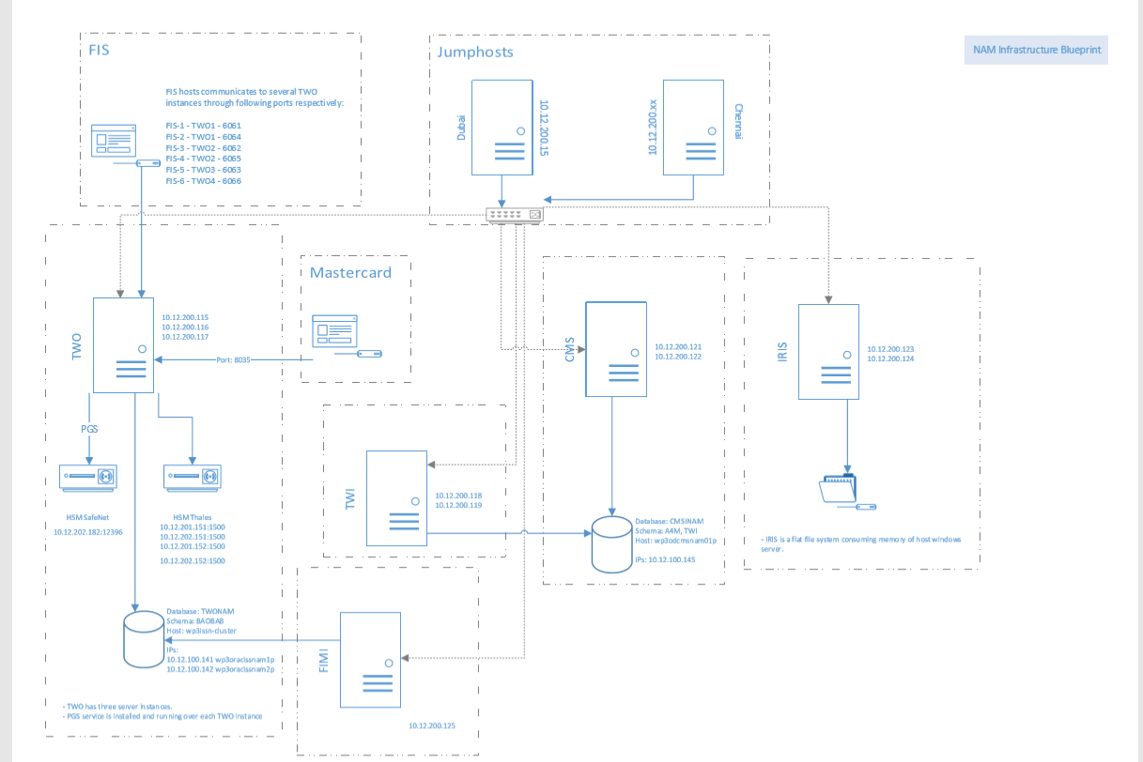

In view of the above mentioned architecture, Datadog integrated with tranzware application such that an agent has been installed and running on each application server and application servers and Datadog binded with agent key exported at time of installation on application server. This key generated through Datadog portal.

## 1.4 About Datadog:

Datadog is a monitoring service for cloud-scale applications, providing monitoring of servers, databases, tools, and services, through a [SaaS](https://en.wikipedia.org/wiki/Software_as_a_service)-based data analytics platform.

For each of the component understanding, please refer below link.

<https://docs.datadoghq.com/>

# Datadog Anatomies Used in NAM Monitoring:

## 2.1 Datadog Agent:

The Datadog Agent is software that runs on your hosts (application servers like TWONAM, CMSINAM etc.). It collects events and metrics from hosts and sends them to Datadog, where you can analyze your monitoring and performance data.

A key generates from Datadog portal under admin rights and exported in server at time of agent installation. This key binds application servers with Datadog portal.

Additionally default DD agent user (dd-agent) created at time of agent installation and is part of installation script. Therefore, all custom script read and execute by this default user on server. The Datadog agent installed in NAM application server is v6.18.1.

For more info: <https://docs.datadoghq.com/agent/>

## 2.2 Custom Metrics:

If a metric is not submitted from one of the [400+ Datadog integrations](https://docs.datadoghq.com/integrations) it is considered a custom metric. Custom metrics help you track your application KPIs: number of visitors, average customer basket size, request latency, or performance distribution for a custom algorithm.

A custom metric is identified **by a unique combination of a metric’s name and tag values (including the host tag).**

All log and file monitors are created and configured as custom metrics. As these scenarios not covered under default Datadog integrations and are specific to tranzware and WDP internal operations.

For default metrics, there are several config yaml formatted files present on application servers. Use Datadog documentation for use of each default metric configuration.

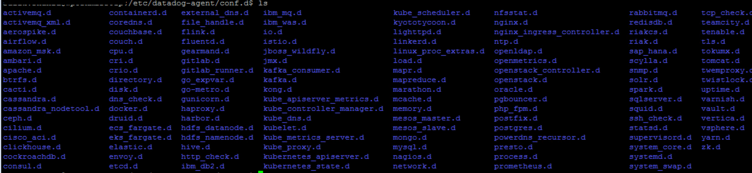

For more info: <https://docs.datadoghq.com/developers/metrics/>

## 2.3 Tags:

Tags are a way of adding dimensions to metrics, so they can be filtered, aggregated, and compared in Datadog visualizations. [Using tags](https://docs.datadoghq.com/tagging/using_tags) enables you to observe aggregate performance across a number of hosts and (optionally) narrow the set further based on specific elements. In summary, tagging is a method to observe aggregate data points.

Tagging binds different data types in Datadog, allowing for correlation and call to action between metrics, traces, and logs.

In YAML files, use a list of strings under the tags key to assign a list of tags. In YAML, lists are defined with two different yet functionally equivalent forms:

|  |
| --- |
| **tags: ["<KEY_1>:<VALUE_1>", "<KEY_2>:<VALUE_2>", "<KEY_3>:<VALUE_3>"]**  **or**  **tags:**  **- "<KEY_1>:<VALUE_1>"**  **- "<KEY_2>:<VALUE_2>"**  **- "<KEY_3>:<VALUE_3>"** |

For more info: <https://docs.datadoghq.com/tagging/>

As part of NAM monitoring, following are the common tags that are used to characterized alerts and group by similar or same kind of alerts to have a relevancy among the alerts. And these tags are part of standard alerting across different application and vertical on board in Datadog (like TW Acquiring, TW Issuing and Corecard)

* client: nam
* env: prod
* module: two, module: cms, module: twi, module: fimi, module: iris
* platform: tw
* type: logmonitor, type: processmonitor, type: filesmonitor, type: osmetricmonitor, type:mv_monitor
* vertical: iss

Additionally, we have used term as secondary and primary tagging subjected to application. All other tags except module (like module: two) would be considered as secondary tag. Primary tag refers to a tag that group by similar application running across different servers.

## 2.4 Common Paths:

* **Path For Datadog Logs:** /var/log/datadog/
* **Path For Custom Python Scripts:** /etc/datadog/check.d/
* **Path For Custom Yaml Scripts:** /etc/datadog/config.d/
* **Path For Oracle Custom Metric Script:** /etc/datadog/config.d/
* **Path For Shell Custom Script:** /opt/datadog/CustomScripts/

## 2.5 Common Commands:

* **To validate oracle config file:** dd-agent datadog-agent check oracle
* **To stop/start/restart datadog agent services:**
* sudo systemctl stop datadog-agent
* sudo systemctl start datadog-agent
* sudo systemctl restart datadog-agent
* **To check datadog agent service status:** sudo systemctl check datadog-agent

# Datadog Parameters Set On NAM Application Servers:

## 3.1 TWO and PGS Application Server

|  |  |  |  |  |  |
| --- | --- | --- | --- | --- | --- |
| ServerIPS | OS TYPE | Primary Tag | Secondary Tag | Agent Directories | Additional Comment |
| 10.12.200.115/116/117 | LINUX | module:two | client:nam, env:prod, module:two, platform: tw, vertical:iss | /opt/etc/datadog/ /opt/datadog/ /var/log/datadog/ | This server is shared between TWO and PGS |

## 3.2 TWCMS and TWRBP Application Server

|  |  |  |  |  |  |
| --- | --- | --- | --- | --- | --- |
| **ServerIPS** | **OS TYPE** | **Primary Tag** | **Secondary Tag** | **Agent Directories** | **Additional Comment** |
| 10.12.200.118/119 | LINUX | module:twcms | client:nam, env:prod, platform: tw, vertical:iss | /opt/etc/datadog/ /opt/datadog/ /var/log/datadog/ | This server is shared between TWCMS and TWRB |

## 3.3 TWINAM Application Server

|  |  |  |  |  |  |
| --- | --- | --- | --- | --- | --- |
| **ServerIPS** | **OS TYPE** | **Primary Tag** | **Secondary Tag** | **Agent Directories** | **Additional Comment** |
| 10.12.200.121/122 | LINUX | module:twi | client:nam, env:prod, platform: tw, vertical:iss | /opt/etc/datadog/ /opt/datadog/ /var/log/datadog/ | - |

## 3.4 FIMI Application Server

|  |  |  |  |  |  |
| --- | --- | --- | --- | --- | --- |
| **ServerIPS** | **OS TYPE** | **Primary Tag** | **Secondary Tag** | **Agent Directories** | **Additional Comment** |
| 10.12.200.125 | LINUX | module:fimi | client:nam, env:prod, platform: tw, vertical:iss | /opt/etc/datadog/ /opt/datadog/ /var/log/datadog/ | - |

## 3.5 IRIS Application Server

|  |  |  |  |  |  |
| --- | --- | --- | --- | --- | --- |
| **ServerIPS** | **OS TYPE** | **Primary Tag** | **Secondary Tag** | **Agent Directories** | **Additional Comment** |
| 10.12.200.123 | LINUX | module:iris | client:nam, env:prod, platform: tw, vertical:iss | /opt/etc/datadog/ /opt/datadog/ /var/log/datadog/ | - |

## 3.6 TWONAM DB NODES

|  |  |  |  |  |  |
| --- | --- | --- | --- | --- | --- |
| **ServerIPS** | **OS TYPE** | **Primary Tag** | **Secondary Tag** | **Agent Directories** | **Additional Comment** |
| 10.12.100.141/142 | LINUX | module:twonam_db | client:nam, env:prod, platform: tw, vertical:iss | /opt/etc/datadog/ /opt/datadog/ /var/log/datadog/ | - |

## 3.7 CMSINAM DB

|  |  |  |  |  |  |
| --- | --- | --- | --- | --- | --- |
| **ServerIPS** | **OS TYPE** | **Primary Tag** | **Secondary Tag** | **Agent Directories** | **Additional Comment** |
| 10.12.100.145 | LINUX | module:cmsinam_db | client:nam, env:prod, platform: tw, vertical:iss | /opt/etc/datadog/ /opt/datadog/ /var/log/datadog/ | - |

# Alerts

## 4.1 Application Process Monitor:

Under this type of monitoring, all application related processes running on application servers are being monitor. This monitor checks status (i.e stop/start) of process. If that process (like flora, itpsrv etc.) not found then alert will be triggered. All monitor configured through Datadog default metric (monitor type => metric) and there is no custom script use. All alerts under this monitoring type tagged as type:processmonitor.

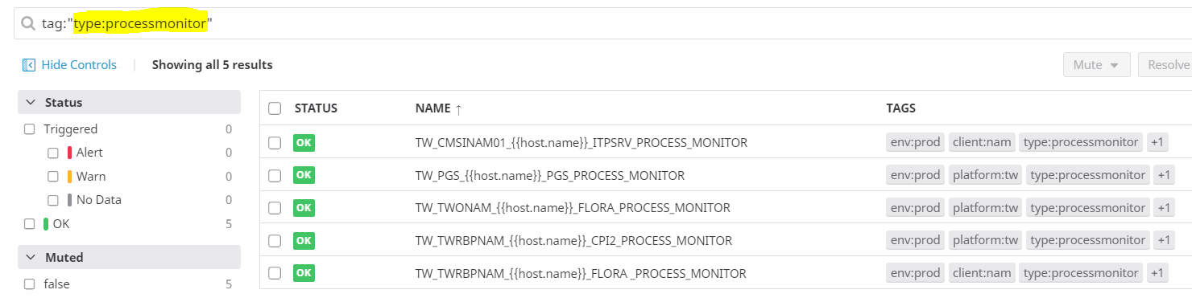

#### 4.1.1 TWONAM FLORA_PROCESS_MONITOR:

This alert checks count of flora process running on each TWO servers. Ideally, there should be four process running on each server (i.e 2 for Main Instance and 2 for Explorer process). If any of the process stop, alert will be triggered specific to that host (server) only.

**For TWONAM (main instance):**

1) /opt/tranzware/TWONAM/BIN.Lnx-x64/flora SYSTEM rs

2) /opt/tranzware/TWONAM/BIN.Lnx-x64/floraitp runFloraRs SYSTEM

**For TWONAM_EXP (explorer):**

1) /opt/tranzware/TWONAM_EXP/BIN.Lnx-x64/flora SYSTEM rs

2) /opt/tranzware/TWONAM_EXP/BIN.Lnx-x64/floraitp runFloraRs SYSTEM

**Alert Configuration:**

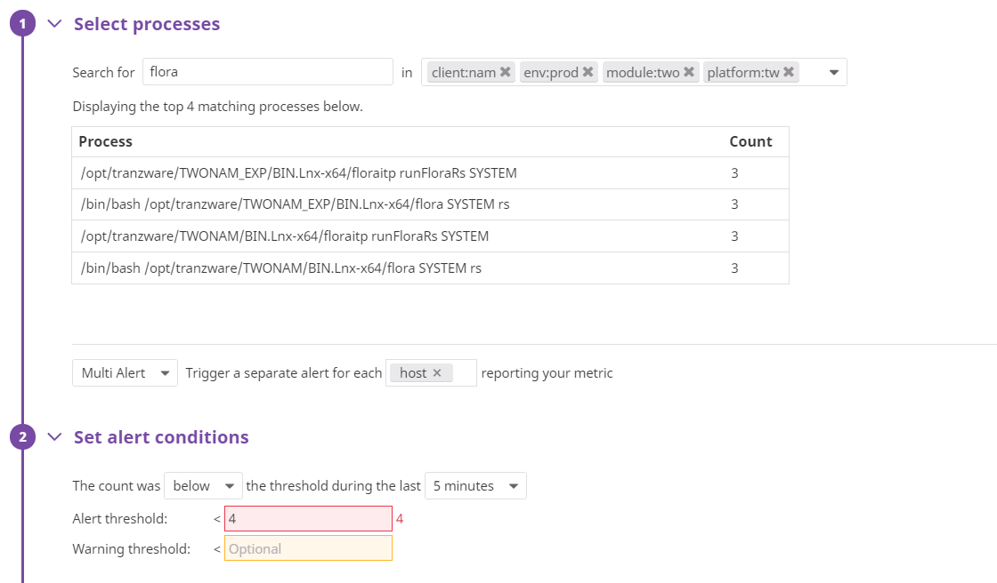

**Sample Alert Email:**

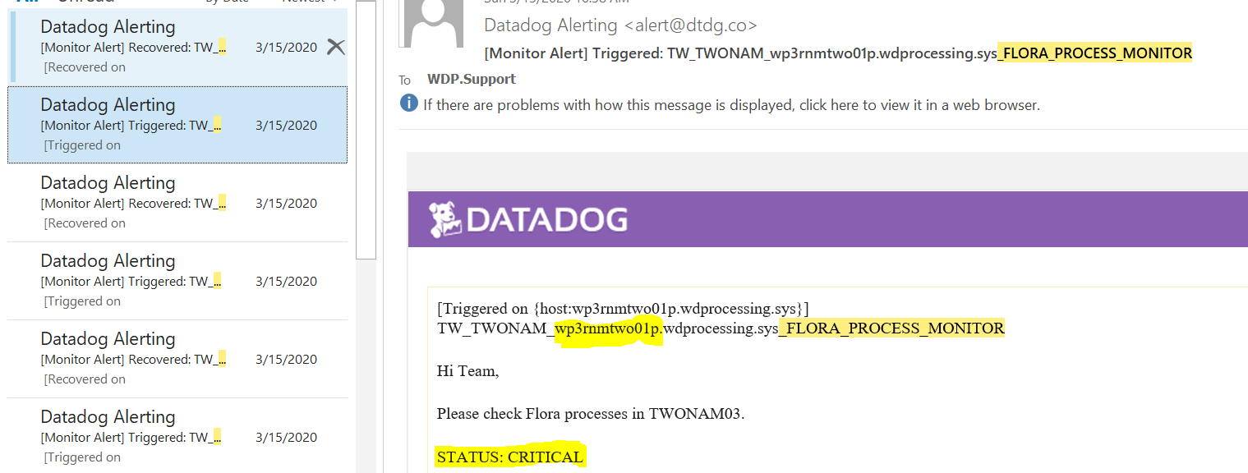

|  |
| --- |
| **Action Item:**  **Instructions:**  Please check below processes.  For TWONAM (main instance):  1) /opt/tranzware/TWONAM/BIN.Lnx-x64/flora SYSTEM rs  2) /opt/tranzware/TWONAM/BIN.Lnx-x64/floraitp runFloraRs SYSTEM  For TWONAM_EXP (explorer):  1) /opt/tranzware/TWONAM_EXP/BIN.Lnx-x64/flora SYSTEM rs  2) /opt/tranzware/TWONAM_EXP/BIN.Lnx-x64/floraitp runFloraRs SYSTEM  If any of the above process is not running, please follow below steps:  **Step 1:** Goto application server:  Server IPs: 10.12.200.115/116/117  Jumpshosts: 10.12.200.115/116  **Step 2:** Goto below path:  1) For TWONAM (main instance): cd /opt/tranzware/TWONAM/BIN.Lnx-x64/  2) For TWONAM_EXP (explorer): cd /opt/tranzware/TWONAM_EXP/BIN.Lnx-x64/  **Step 3:** Execute below command.  1) For TWONAM (main instance): ./startTWONAM.sh  2) For TWONAM_EXP (explorer): ./startTWONAM_EXP.sh |

#### 4.1.2 ITPSRV_PROCESS_MONITOR

ITPSRV process is of CMSINAM application process. This alert checks count of process running in TWCMS server. Ideally, there should be two process running on server subjected to ITPSRV. If any of the process not running, alert will be triggered.

Below are the two processes:

/opt/tranzware/CMSNAM/CPI2/LINUX/bin/itpsrv run tcp 6050 -dbg stdout -log extractrefresh..

/opt/tranzware/CMSNAM/CPI2/LINUX/BIN64/itpsrv run tcp 1250 -dbg CMSNAM.log

Please be noted that there are two servers for CMSINAM. However, one of the server (10.12.200.122) is currently not in used and alert is only configured on 10.12.200.121

**Alert Configuration:**

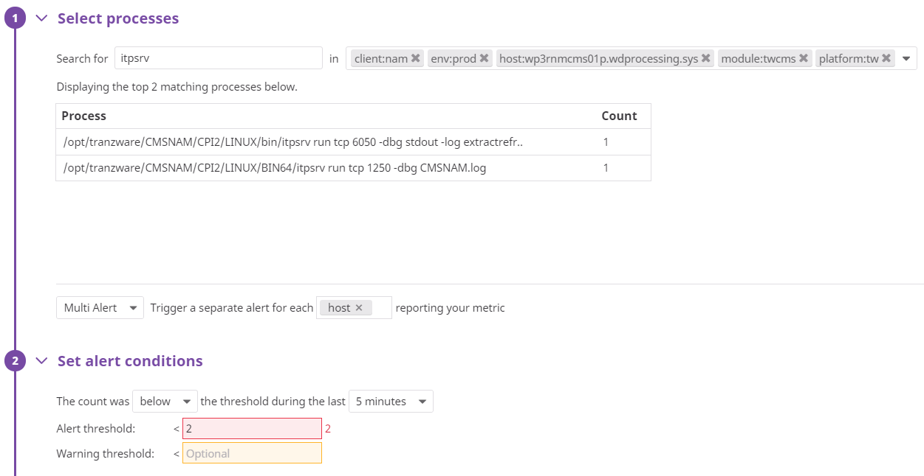

**Sample Email:**

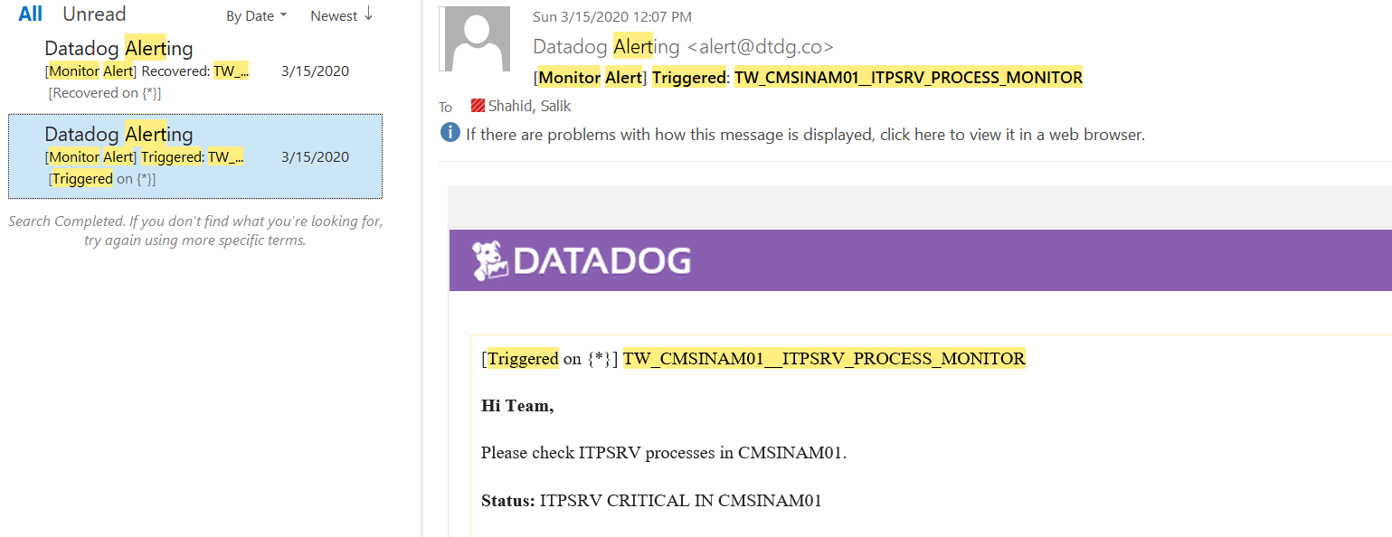

|  |
| --- |
| **Action Item:**  **Instructions:**  Please check below processes.  1) /opt/tranzware/CMSNAM/CPI2/LINUX/BIN64/itpsrv run tcp 1250 -dbg CMSNAM.log  2) /opt/tranzware/CMSNAM/CPI2/LINUX/bin/itpsrv run tcp 6050 -dbg stdout -log extractrefreshservice.log  **Step 1:** Goto application server  Server IPs: 10.12.200.118  **Step 2:** Goto below paths  1) FOR CMS : /opt/tranzware/CMSNAM/CPI2/LINUX/BIN64  2) FOR Extract/Refresh process: /opt/tranzware/CMSNAM/CPI2/LINUX/bin  **Step 3:** Execute below scripts  FOR CMS: ./startCMSNAM.sh  FOR Extract/Refresh process: ./runcms rs & |

#### 4.1.3 PGS_PROCESS_MONITOR

This alert checks PGS process in TWONAM/PGS server. Ideally, there should be one process running on each server.

Below is the process.

Command: ps -ef | grep PGS

Output: java -classpath ./PGS.jar:./lib/CompassJUtils.jar:./lib/jcprov.jar:./lib/jcprov_safen..

**Alert Configuration:**

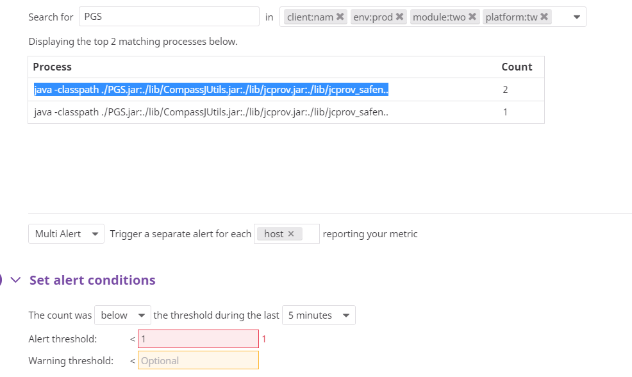

**Sample Alert:**

**N/A**

|  |
| --- |
| **Action Item:**  **Instructions:**  Please check below process.  Command: ps -ef | grep PGS  Output: java -classpath ./PGS.jar:./lib/CompassJUtils.jar:./lib/jcprov.jar:./lib/jcprov_safen..  If the above process is not running, please follow below steps:  **Step 1:** Goto application server:  **10.12.200.115/116/117**  **Step 2:** Goto below path:  /opt/trazware/PGS/  **Step 3:** Execute below command.  ./startup.sh rs & |

#### 4.1.4 CPI2_PROCESS_MONITOR

This alert check TWRBP CPI2 service running on CMSINAM/TWRBP server. Ideally, there should be one service running. Below is the process.

**/opt/tranzware/TWRBPNAMCPI/./cpi2**

**Alert Configuration:**

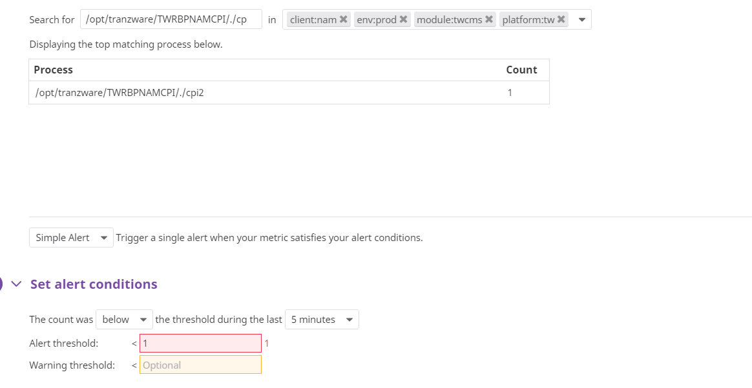

**Sample Alert:**

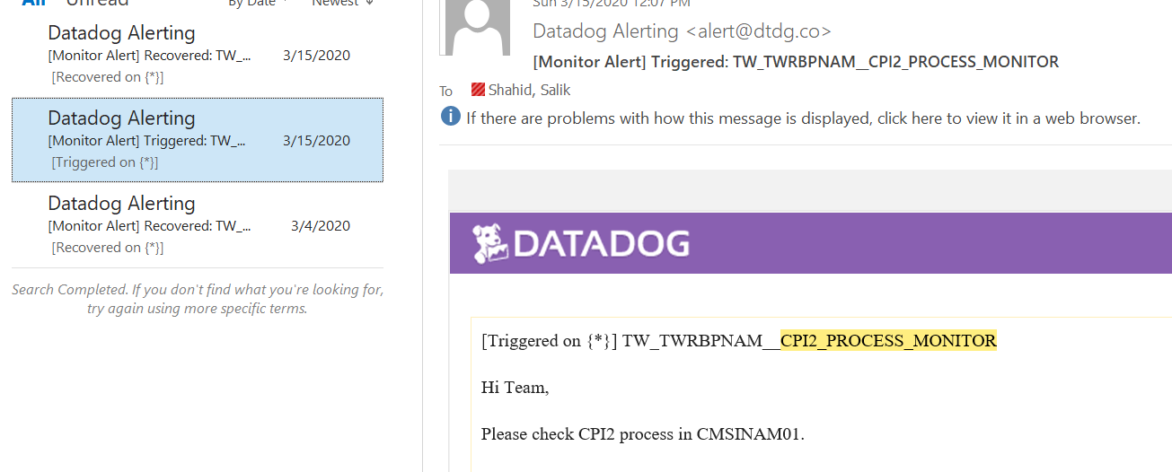

|  |
| --- |
| **Action Item:**  **Instructions:**  **Step 1:** Goto application server.  Server IPs: 10.12.200.118  **Step 2:** Please check below processes  /opt/tranzware/TWRBPNAMCPI/./cpi2  **Step 3:** Goto below path  /opt/tranzware/TWRBPNAMCPI/  **Step 4:** Execute below scripts  ./server rs & |

#### 4.1.5 TWRBNAM_FLORA_PROCESS_MONITOR

This alert check TWRBP flora process on CMSINAM server. Ideally, there should be three process running. Below are the processes.

**./floraitp runFloraRs SYSTEM rs**

**/bin/bash /opt/tranzware/TWRBPNAM/BIN.Lnx-x64/flora SYSTEM rs**

**/bin/sh /opt/tranzware/TWRBPNAM/BIN.Lnx-x64/florars SYSTEM rs**

**Alert Configuration:**

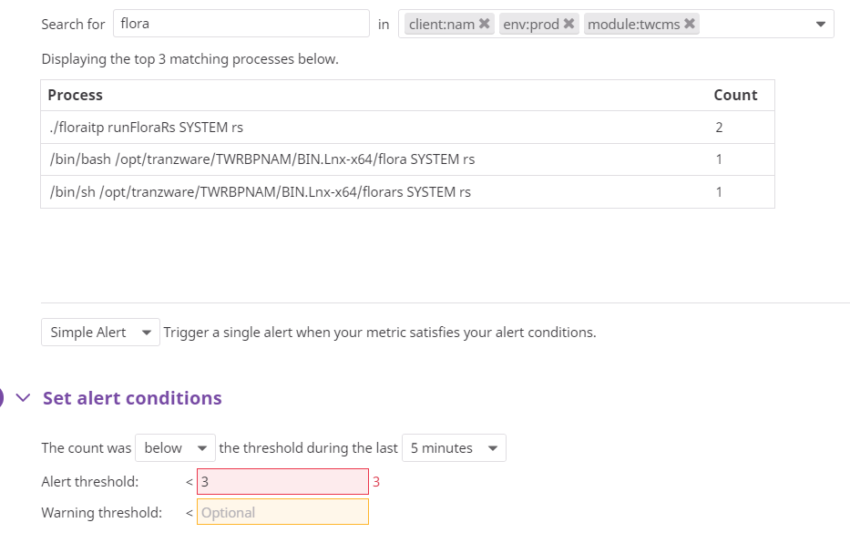

**Sample Email:**

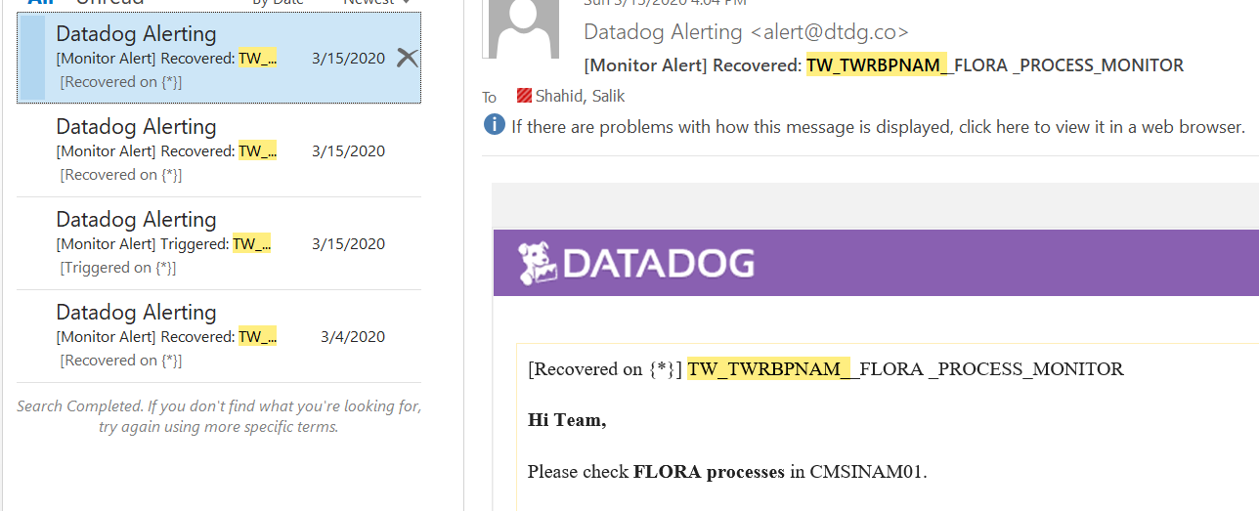

|  |
| --- |
| **Action Item:**  **Instructions:**  **Step 1:** Goto application server.  Server IPs: 10.12.200.118  **Step2:** Please check below processes.  Process Names:  1) /opt/tranzware/TWRBPNAM/BIN.Lnx-x64/flora SYSTEM rs  2) /opt/tranzware/TWRBPNAM/BIN.Lnx-x64/florars SYSTEM rs  3) ./floraitp runFloraRs SYSTEM rs  Command: ps –ef | grep flora  **Step 3:** Goto below paths:  /opt/tranzware/TWRBPNAM/BIN.Lnx-x64  **Step 4:** Execute below scripts  ./STARTTWRBPNAM.sh |

#### 4.1.6 TW_TWONAM_NYCE_STUNNEL_PROCESS_MONITOR

This alert checks stunnel process for NYCE connection on TWONAM servers. Since there are two ports open between NYCE and TWONAM so total 12 process running on twonam server (i.e 6 each for each port).

NYCE connects to Stunnel on ports (5061,5062,5063,5064,5065,5066) and then stunnel connects to TWONAM servers on (6061,6062,6063,6064,6065,6066). For each of the respective ports with servers, please refer cfg file on TWONAM server.

**Alert Configuration:**

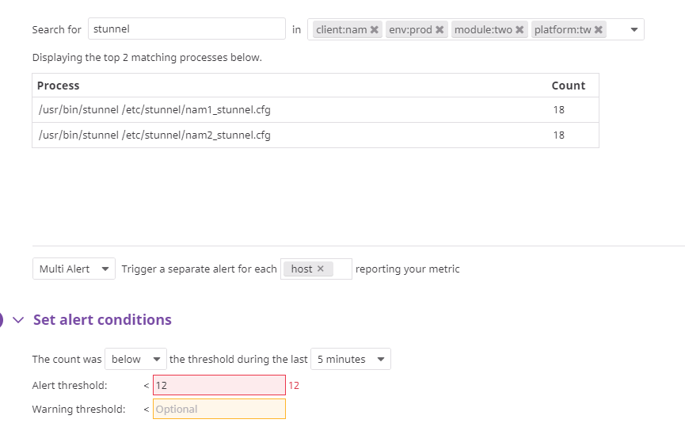

**Sample Email:**

**N/A**

|  |
| --- |
| **Action Item:**  **Instructions:**  Please check below process.  Command: ps -ef | grep stunnel  1) /usr/bin/stunnel /etc/stunnel/nam1_stunnel.cfg (Count for this process should be 6)  2) /usr/bin/stunnel /etc/stunnel/nam2_stunnel.cfg (Count for this process should be 6)  Logs Path:  1) /var/log/stunnel/nam1/nam_stunnel.log (For nam1 process)  2) /var/log/stunnel/nam2/nam_stunnel.log (For nam2 process)  If any of the above process is not running, please engage Linux team. |

## 4.2 Log Monitor:

Under this type of monitoring, Datadog checks particular string (like ORA, exception etc) in application debug logs. If the string found, alert will be triggered. All alerts under this monitoring type tagged as type:processmonitor. These alerts have been configured through custom scripts and each alert contains python, yaml and pyc script present in below directories on server.

For yaml: /etc/Datadog/conf.d

For python and pyc: /etc/Datadog/check.d/

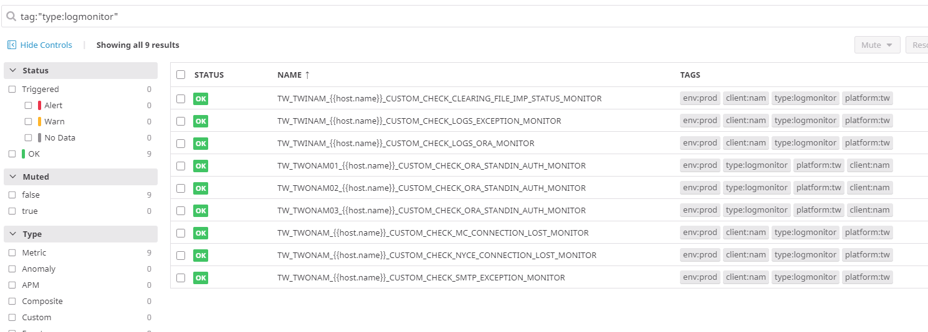

#### 4.2.1 TW_TWINAM_CUSTOM_CHECK_LOGS_EXCEPTION_MONITOR

This alert checks “exception” string in application debug logs. If there would be any exception occurred on in any of the logs present in below mentioned paths, alert will be triggered accordingly.

**Path:**

/opt/tranzware/exchange/twi/Trace/

**Logs:**

* INST_TRACE.log
* Export_Processor_TIP_Trace.log
* Cutoff_Processor_Trace.log
* BINWriter_NAM_MC_Trace.log
* Import_Processor_IPM_Trace.log
* Transaction_Processor_Trace.log
* BINLoaderMC_Trace.log
* SMTP_Notification_Unit.log
* SMTP_Notification_Driver.log
* SMTP_Notification_Driver.log

**Alert Configuration:**

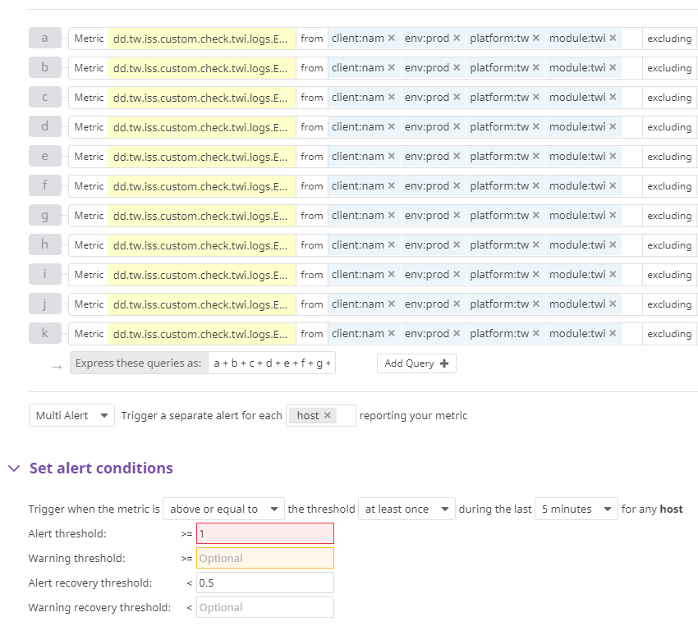

**Sample Email:**

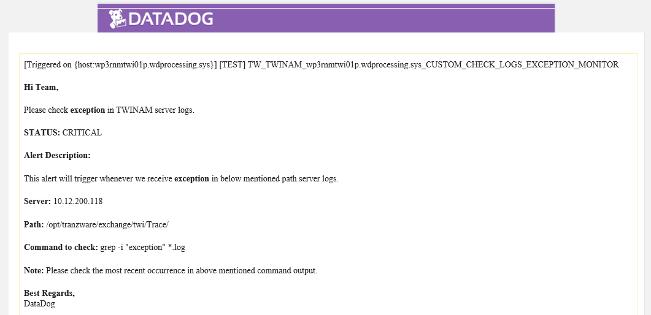

#### 4.2.2 TW_TWINAM_CUSTOM_CHECK_LOGS_ORA_MONITOR

This alert checks “ORA” string. If there would be ORA error occurred on in any of the logs present in below mentioned paths, alert will be triggered accordingly.

**Path:**

/opt/tranzware/exchange/twi/Trace/

**Logs:**

* INST_TRACE.log
* Export_Processor_TIP_Trace.log
* Cutoff_Processor_Trace.log
* BINWriter_NAM_MC_Trace.log
* Import_Processor_IPM_Trace.log
* Transaction_Processor_Trace.log
* BINLoaderMC_Trace.log
* SMTP_Notification_Unit.log
* SMTP_Notification_Driver.log
* SMTP_Notification_Driver.log

**Alert Configuration:**

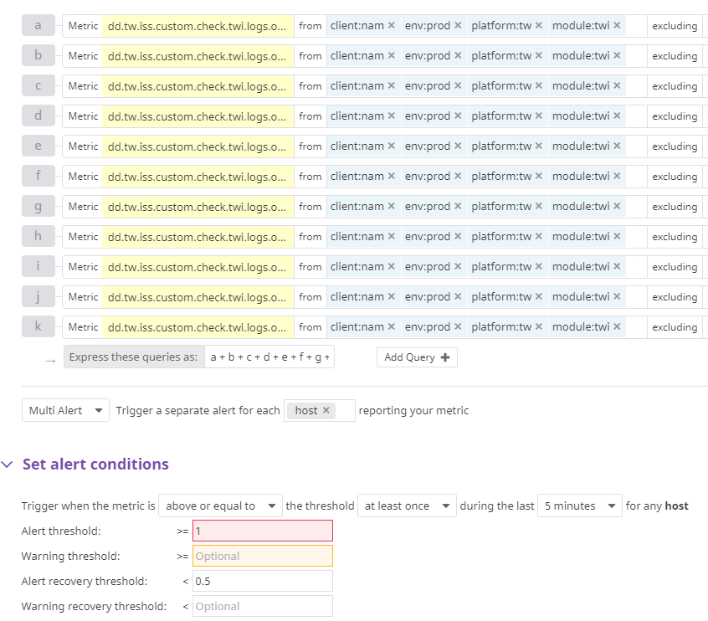

**Sample Email:**

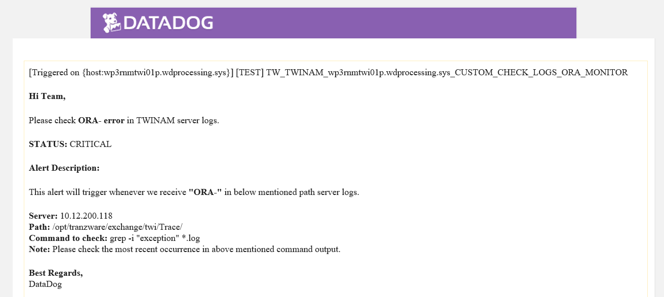

#### 4.2.3 TW_TWONAM_CUSTOM_CHECK_ORA_STANDIN_AUTH_MONITOR

This alert checks “ORA” string. If there would be any ORA error occurred on in any StandIN logs present in TWONAM server, alert will be triggered accordingly. This alert separately configured for each TWONAM server.

**Alert Configuration:**

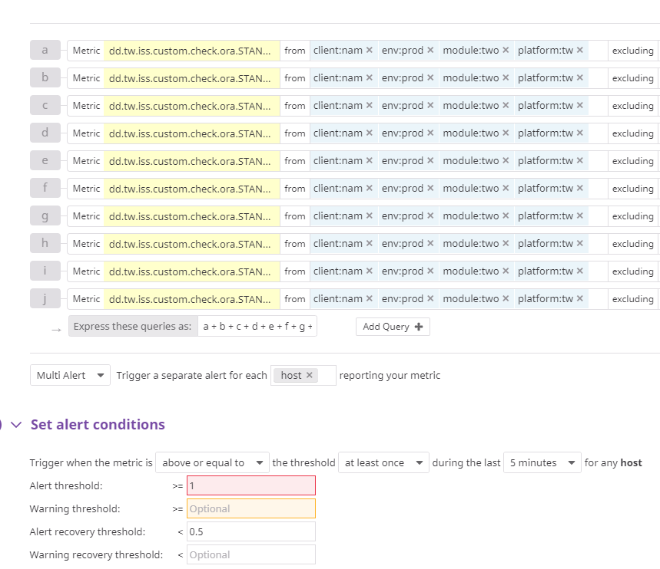

**Sample Email:**

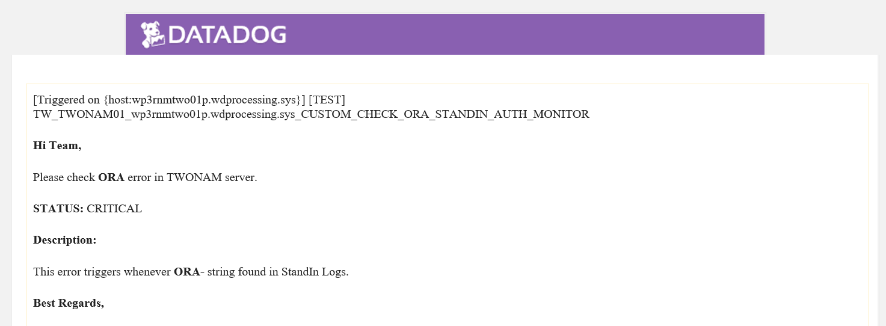

#### 4.2.4 TW_TWONAM_CUSTOM_CHECK_MC_CONNECTION_LOST_MONITOR

This alert checks “Connection Lost” string. If there would be any connection lost occurred on in any NYCE logs present in TWONAM server, alert will be triggered accordingly.

**Alert Configuration:**

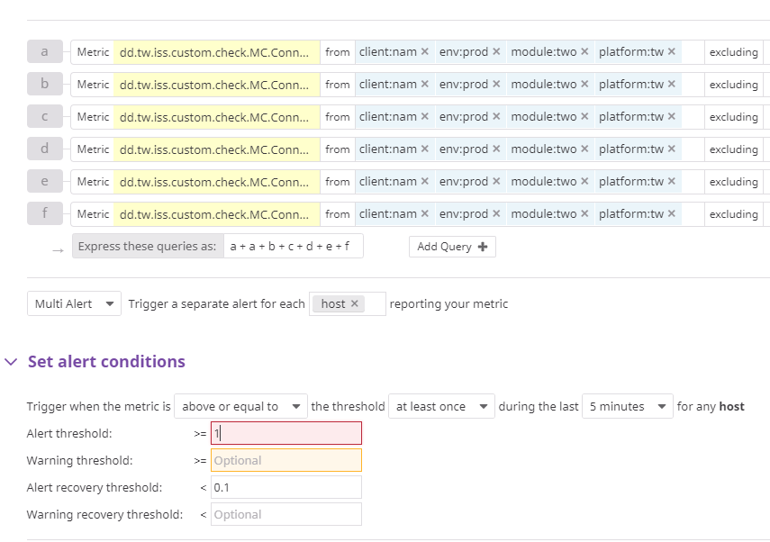

**Sample Email:**

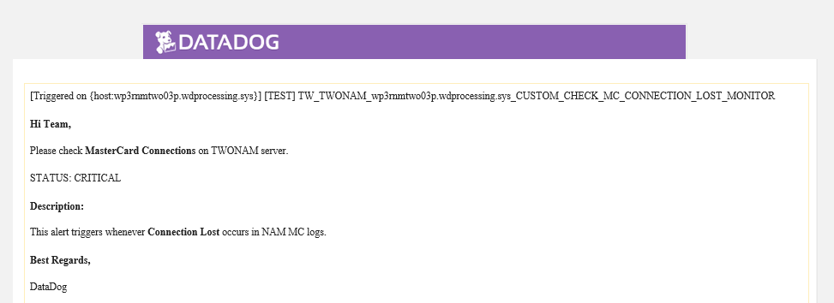

#### 4.2.5 TW_TWONAM_CUSTOM_CHECK_NYCE_CONNECTION_LOST_MONITOR

This alert checks “Connection Lost” string in MasterCard logs. If there would be any connection lost occurred on in any MC logs present in TWONAM server, alert will be triggered accordingly.

**Alert Configuration:**

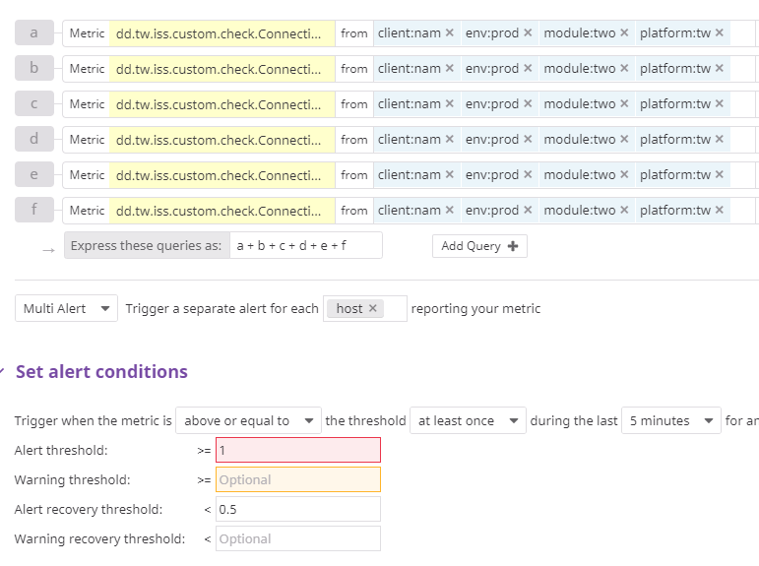

**Sample Email:**

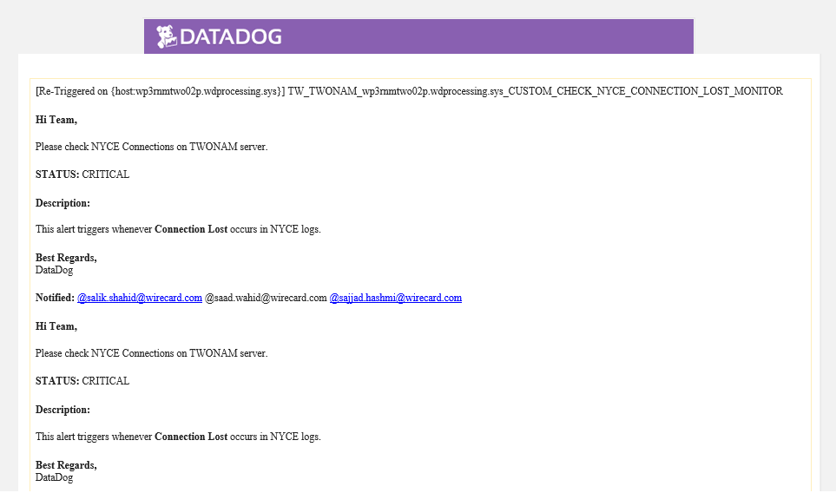

#### 4.2.6 TW_TWONAM_CUSTOM_CHECK_SMTP_EXCEPTION_MONITOR

This alert checks “exception” string. If there would be any exception occurred on in any SMTP logs present in TWONAM server, alert will be triggered accordingly.

**Alert Configuration:**

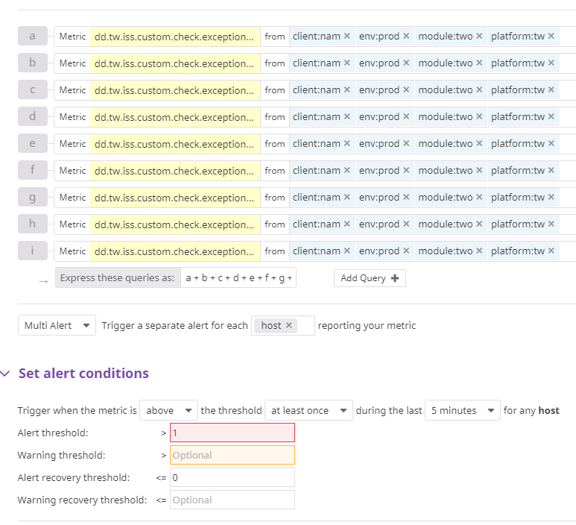

**Sample Email:**

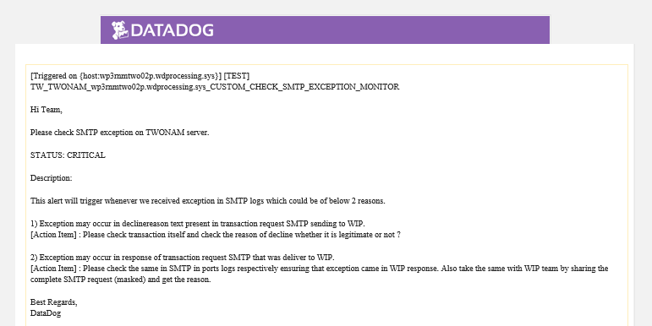

## 4.3 File Monitor

Under this alert type, Datadog checks particular at some particular path. All alerts under this monitoring type tagged as type:filemonitor. These alerts have been configured through custom scripts and each alert contains python, yaml and pyc script present in below directories on server.

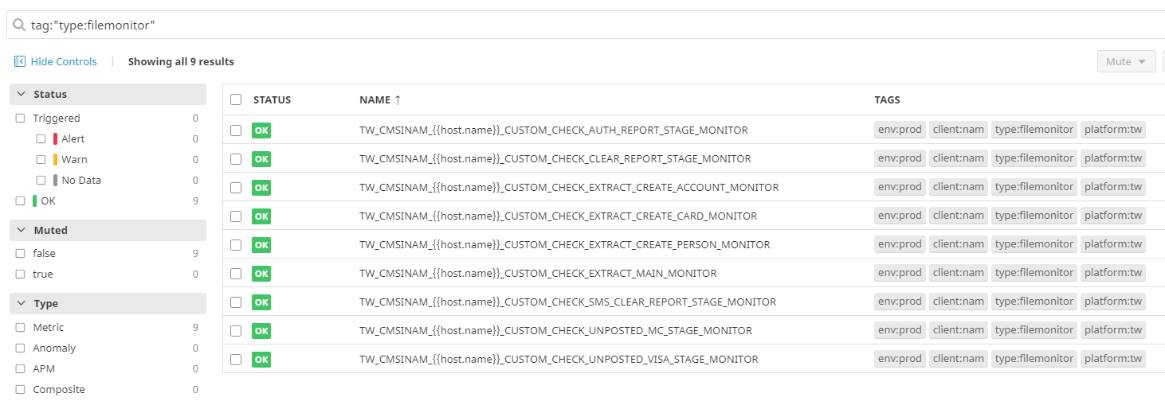

#### 4.3.1 TW_CMSINAM_CUSTOM_CHECK_AUTH_REPORT_STAGE_MONITOR

This error triggers whenever AUTH_YYYYMMDDHH24MISS.txt.done not present in backup folder as the opswise last task is to move file into the backup folder after staging on SFTP If file not in backup then it is assume that file not stage to client over SFTP. Therefore, alert will be triggered.

**Server:** 10.12.200.121

**Path:** /opt/tranzware/exchange/cms2client/wdni/reports/backup/

**Alert Configuration:**

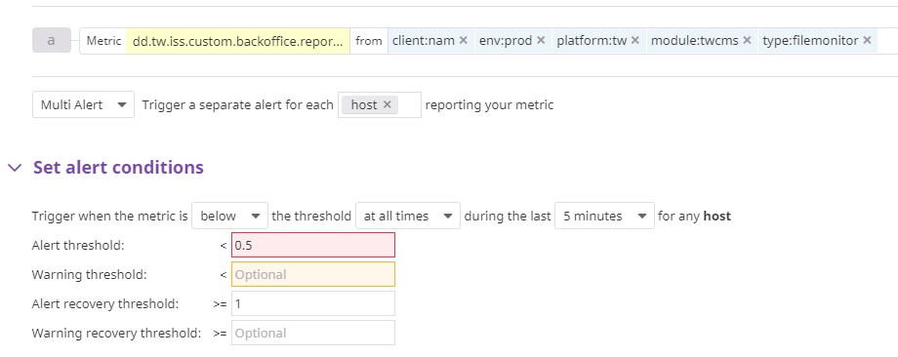

**Sample Email:**

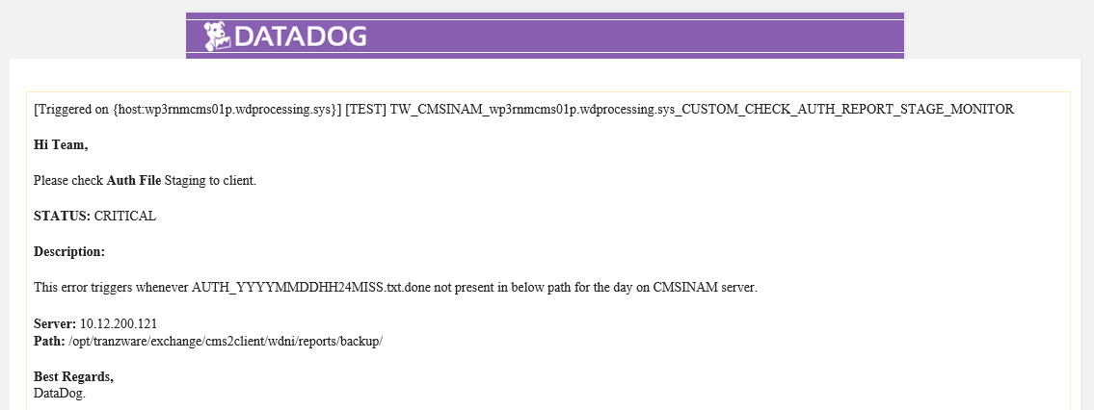

#### 4.3.2 TW_CMSINAM_CUSTOM_CHECK_CLEAR_REPORT_STAGE_MONITOR

This error triggers whenever CLEARING_YYYYMMDDHH24MISS.txt.done not present in backup folder as the opswise last task is to move file into the backup folder after staging on SFTP If file not in backup then it is assume that file not stage to client over SFTP. Therefore, alert will be triggered.

**Server:** 10.12.200.121

**Path:** /opt/tranzware/exchange/cms2client/wdni/reports/backup/

**Alert Configuration:**

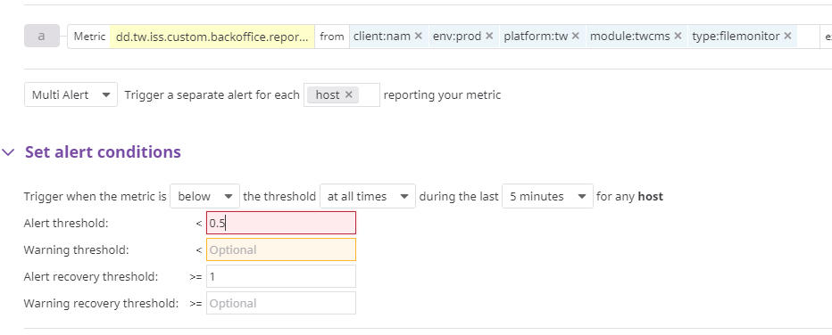

**Sample Email:**

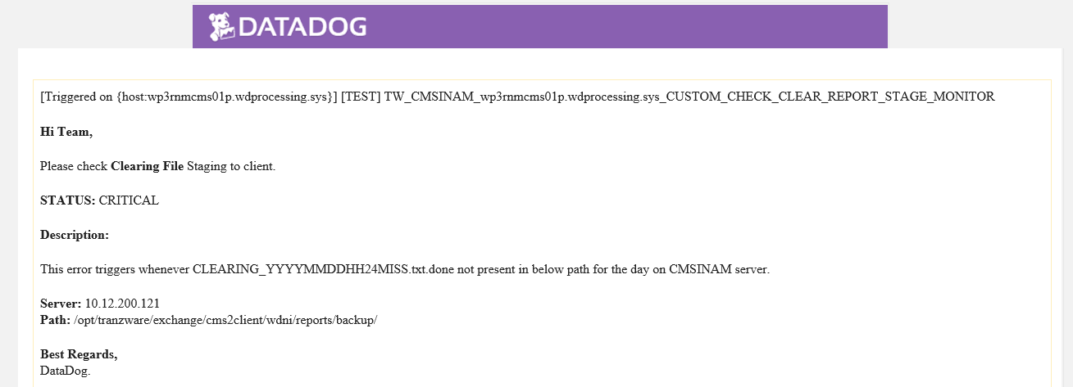

#### 4.3.3 TW_CMSINAM_CUSTOM_CHECK_SMS_CLEAR_REPORT_STAGE_MONITOR

This error triggers whenever SMS_CLEARING_YYYYMMDDHH24MISS.txt.done not present in backup folder as the opswise last task is to move file into the backup folder after staging on SFTP If file not in backup then it is assume that file not stage to client over SFTP. Therefore, alert will be triggered.

**Server:** 10.12.200.121

**Path:** /opt/tranzware/exchange/cms2client/wdni/reports/backup/

**Alert Configuration:**

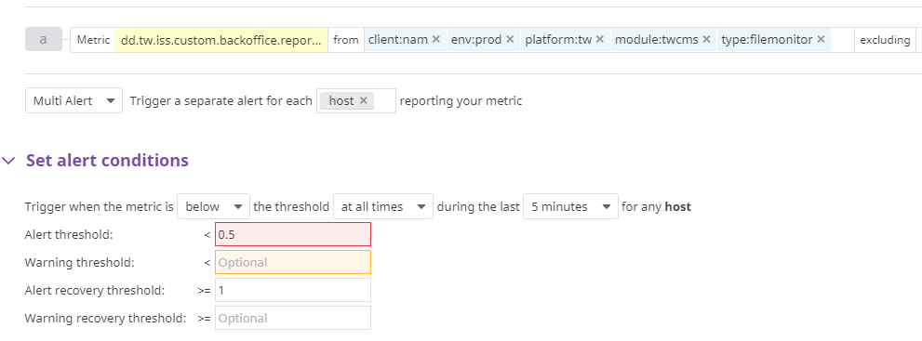

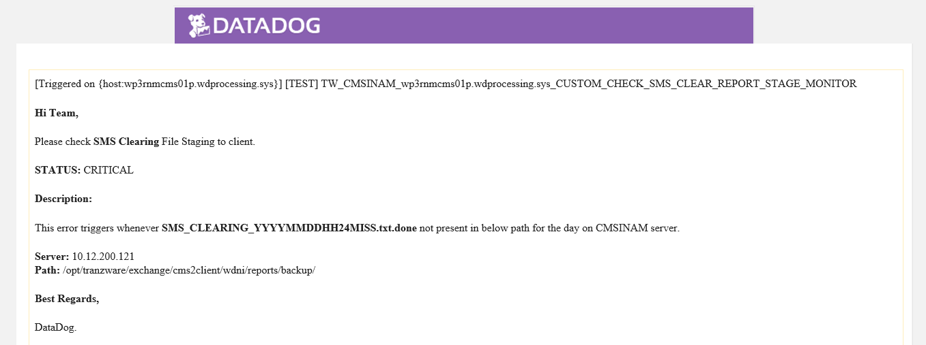

**Sample Email:**

**N/A**

#### 4.3.4 TW_CMSINAM_CUSTOM_CHECK_UNPOSTED_MC_STAGE_MONITOR

This error triggers whenever wdccp_unposted_txn_MC_YYYYMMDDHH24MISS.txt.done not present in backup folder as the opswise last task is to move file into the backup folder after staging on SFTP. If file not in backup then it is assume that file not stage to client over SFTP. Therefore, alert will be triggered.

Server: 10.12.200.121

Path: /opt/tranzware/exchange/cms2client/wdni/reports/backup/

**Alert Configuration:**

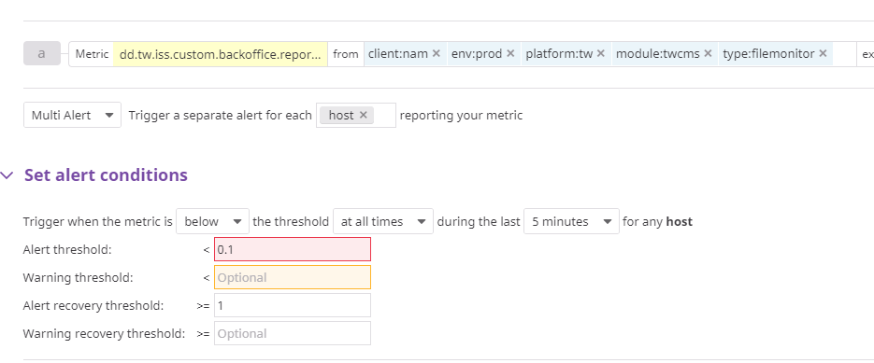

**Sample Email:**

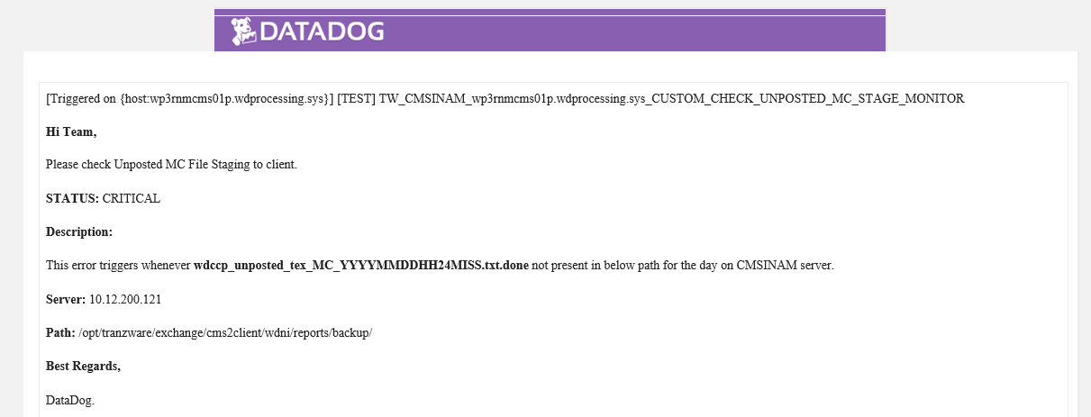

#### 4.3.5 TW_CMSINAM_CUSTOM_CHECK_UNPOSTED_VISA_STAGE_MONITOR

This error triggers whenever wdccp_unposted_tex_VISA_YYYYMMDDHH24MISS.txt.done not present in backup folder as the opswise last task is to move file into the backup folder after staging on SFTP If file not in backup then it is assume that file not stage to client over SFTP. Therefore, alert will be triggered.

Server: 10.12.200.121

Path: /opt/tranzware/exchange/cms2client/wdni/reports/backup/

**Alert Configuration:**

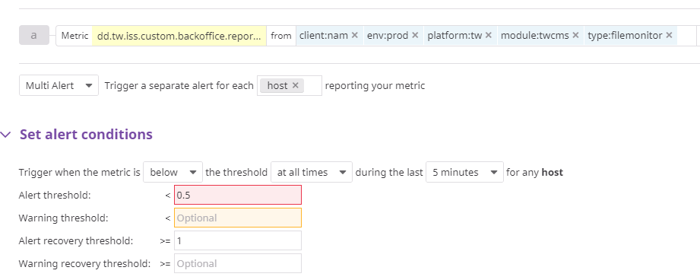

**Sample Email:**

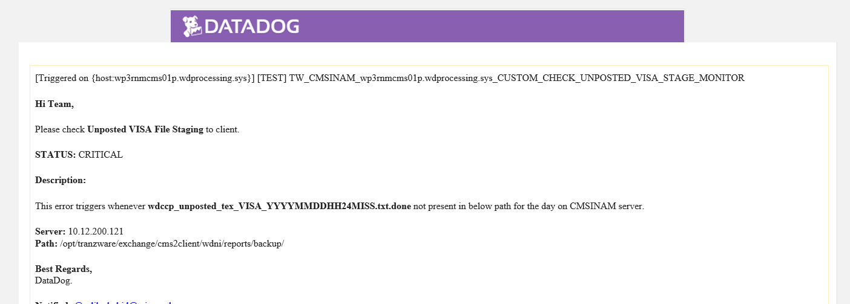

#### 4.3.6 TW_CMSINAM_CUSTOM_CHECK_EXTRACT_CREATE_ACCOUNT_MONITOR

This alert triggers whenever WDNI_YYMMDD001_2_525.dat not present in below path for the day on CMSINAM server. This file always move to back up after successful extract process on CMSINAM. Please check the reason and do the needful if required.

**Server:** 10.12.200.121

**Path:** /opt/tranzware/exchange/two2cms/wdni/extract/2_525_Create_Account/BACKUP/

**Alert Configuration:**

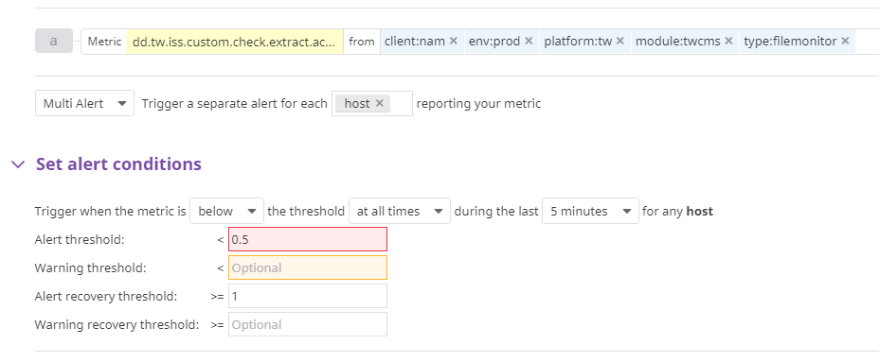

**Sample Email:**

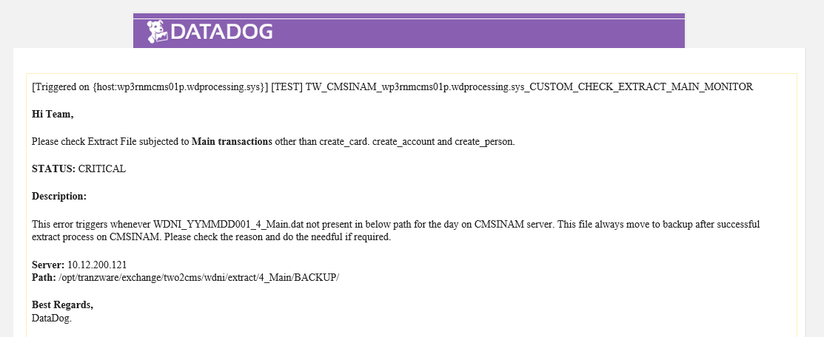

#### 4.3.7 TW_CMSINAM_CUSTOM_CHECK_EXTRACT_CREATE_CARD_MONITOR

This alert triggers whenever WDNI_YYMMDD001_3_336.dat not present in below path for the day on CMSINAM server. This file always move to back up after successful extract process on CMSINAM. Please check the reason and do the needful if required.

**Server:** 10.12.200.121

**Path:** /opt/tranzware/exchange/two2cms/wdni/extract/3_336_Create_Card/BACKUP/

**Alert Configuration:**



**Sample Email:**

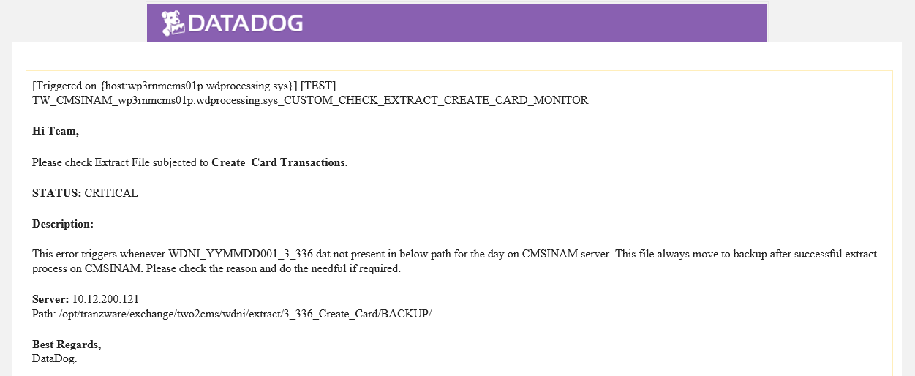

#### 4.3.8 TW_CMSINAM_CUSTOM_CHECK_EXTRACT_CREATE_PERSON_MONITOR

This alert triggers whenever WDNI_YYMMDD001_1_1502.dat not present in below path for the day on CMSINAM server. This file always move to back up after successful extract process on CMSINAM. Please check the reason and do the needful if required.

**Server:** 10.12.200.121

**Path:** /opt/tranzware/exchange/two2cms/wdni/extract/1_1502_Create_Person/BACKUP/

**Alert Configuration:**



**Sample Email:**

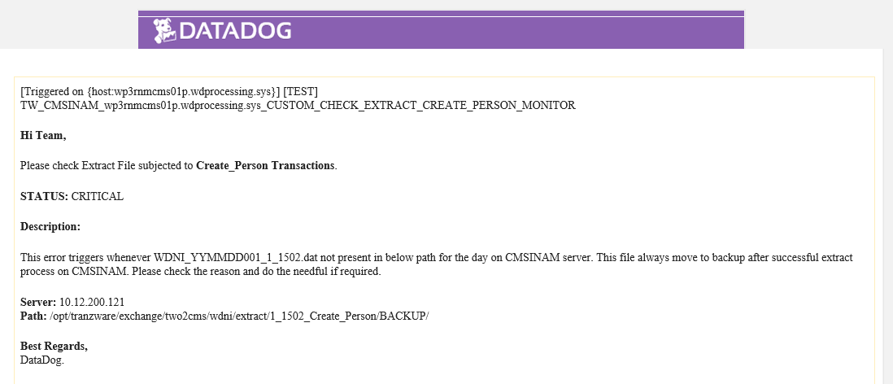

#### 4.3.9 TW_CMSINAM_CUSTOM_CHECK_EXTRACT_CREATE_MAIN_MONITOR

This alert triggers whenever WDNI_YYMMDD001_4_Main.dat not present in below path for the day on CMSINAM server. This file always move to back up after successful extract process on CMSINAM. Please check the reason and do the needful if required.

**Server:** 10.12.200.121

**Path:** /opt/tranzware/exchange/two2cms/wdni/extract/4_Main/BACKUP/

**Alert Configuration:**



**Sample Email:**

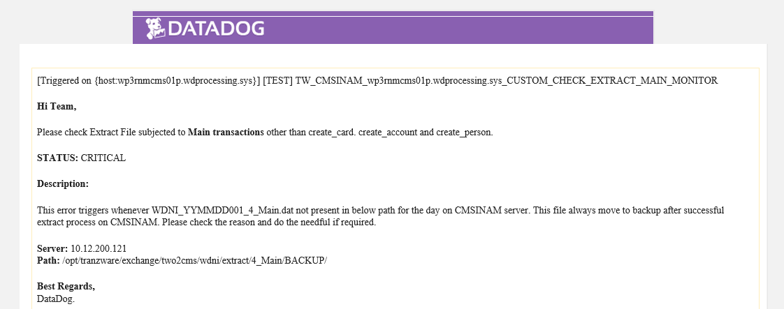

## 4.4 MV Monitor

Under this alert type, metallized views and Datadog agent has been created on each DB nodes. All metrics has been configured in one config file present in /etc/Datadog/conf.d/oracle.d/config.yaml.

#### 4.4.1 CUSTOM_CHECK_MC_OAS_FILE_EXPORT_TWI_MONITOR

This alert checks OAS file export status from TWI for the day. This report exports everyday @03:10am. It is checking the count on DB level. If the count is 0, then alert will be triggered. Please be noted that if the file export other than that time (i.e previous day twice exported) and for that day no file generated then also alert will be generated.

|  |
| --- |
| **MV NAME:** TWI.DD_MV_NAM_OAS_EXPORT_COUNT_TWI  **DB NAME:** CMSINAM – WP3  **Query:**  SELECT CASE  WHEN TO_CHAR (SYSDATE - 1, 'HH24:MI') < '03:15' THEN 1 ELSE COUNT (*)  END MC_NAM_OAS_EXP_FILE_COUNT FROM twi.batch  WHERE TO_DATE (TO_CHAR (createdtime, 'DD-MON-YYYY'), 'DD-MON-YYYY') =  TO_DATE (TO_CHAR (SYSDATE, 'DD-MON-YYYY'), 'DD-MON-YYYY') AND filename LIKE 'MC_to_OAS%'; |

**Alert Configuration:**

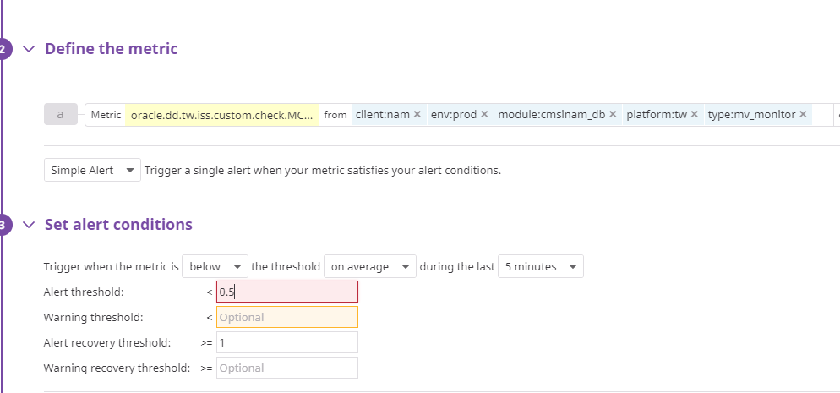

**Sample Email:**

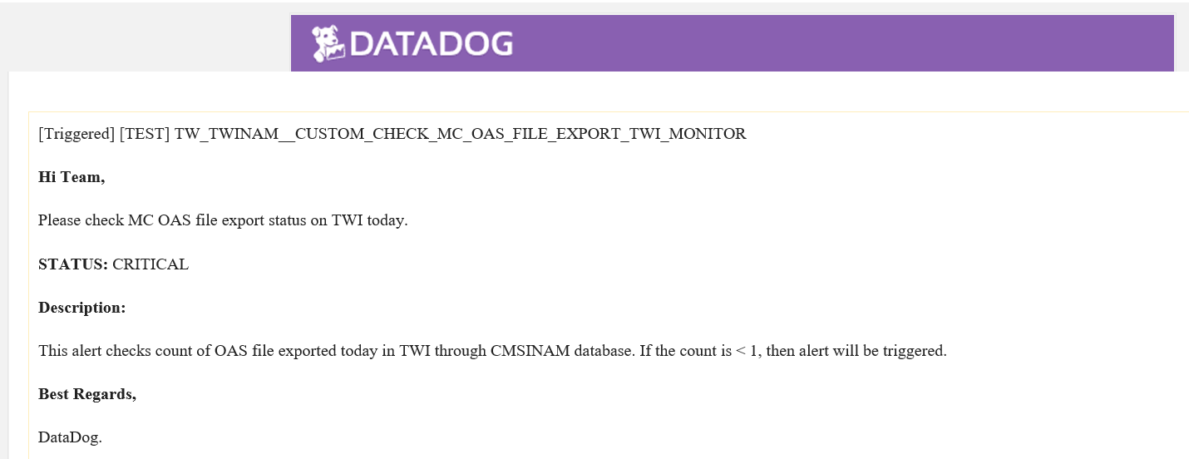

#### 4.4.2 CUSTOM_CHECK_MC_TIP_FILE_EXPORT_TWI_MONITOR

This alert checks TIP file export status on TWI for the day. This file contains all clearing received and imports in TWCMS to post clearing on customer account. Please be noted that if the file export other than that time (i.e previous day twice exported) and for that day no file generated then also alert will be generated. This alert checks count on DB level. If the count is 0, then alert will be triggered.

|  |
| --- |
| **MV NAME:** TWI.DD_MV_NAM_TIP_EXPORT_COUNT_TWI  **DB NAME:** CMSINAM – WP3  **Query:**  SELECT CASE  WHEN TO_CHAR (SYSDATE - 1, 'HH24:MI') < '03:15' THEN 1  ELSE COUNT (*)  END  MC_NAM_TIP_EXP_FILE_COUNT  FROM twi.batch  WHERE TO_DATE (TO_CHAR (createdtime, 'DD-MON-YYYY'), 'DD-MON-YYYY') =  TO_DATE (TO_CHAR (SYSDATE, 'DD-MON-YYYY'), 'DD-MON-YYYY')  AND filename LIKE 'MC_CS_to_WDNI%'; |

**Alert Configuration:**

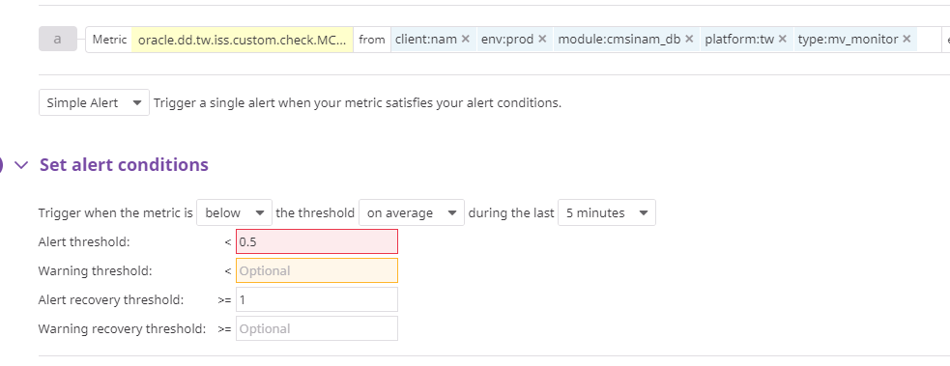

**Sample Email:**

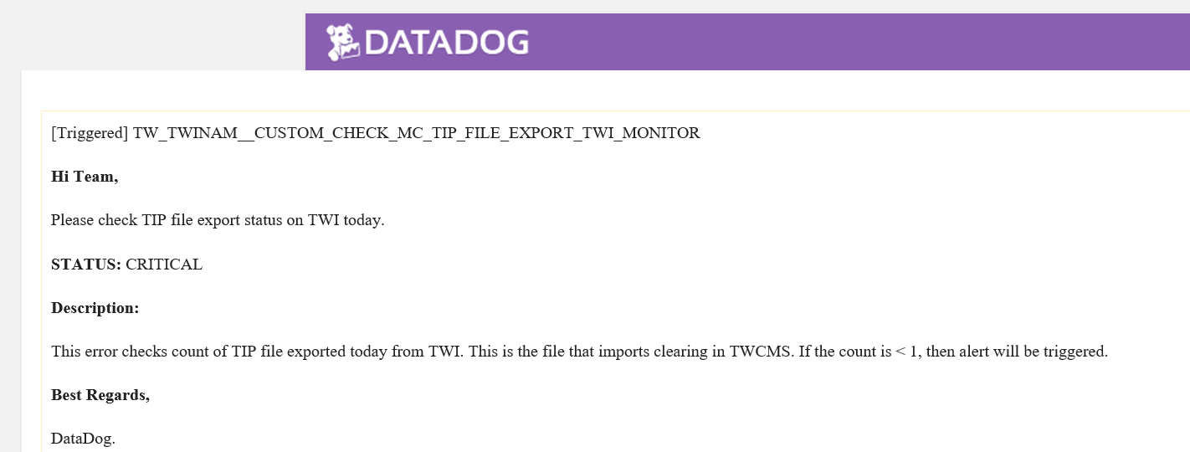

#### 4.4.3 CUSTOM_CHECK_MC_TT112_FILE_IMPORT_TWI_MONITOR

This alert checks TT112 file import status on TWI for the day. This file contains all clearing received from MasterCard to be imported in TWI. Every day six file import subjected to 6 cycles. Everyday @11:30 pm, file wiil be generated. This alert checks count on DB level. If the count is less than 6, then alert will be triggered.

|  |
| --- |
| **MV NAME:** TWI.DD_MV_TT112_IMPORT_COUNT_TWI  **DB NAME:** CMSINAM – WP3  **Query:**  SELECT CASE  WHEN TO_CHAR (SYSDATE - 1, 'DAY') = 'SUNDAY ' THEN 6  ELSE COUNT (*)  END  MC_NAM_TT112_IMP_FILE_COUNT  FROM twi.batch  WHERE TO_DATE (TO_CHAR (createdtime, 'DD-MON-YYYY'), 'DD-MON-YYYY') >=  TO_DATE (TO_CHAR (SYSDATE - 1, 'DD-MON-YYYY'),  'DD-MON-YYYY')  AND filename LIKE 'TT112T0%'; |

**Alert Configuration:**

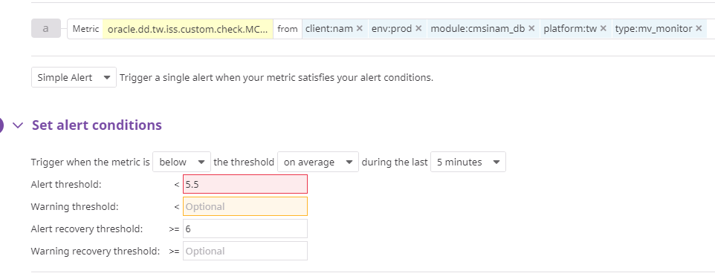

**Sample Email**

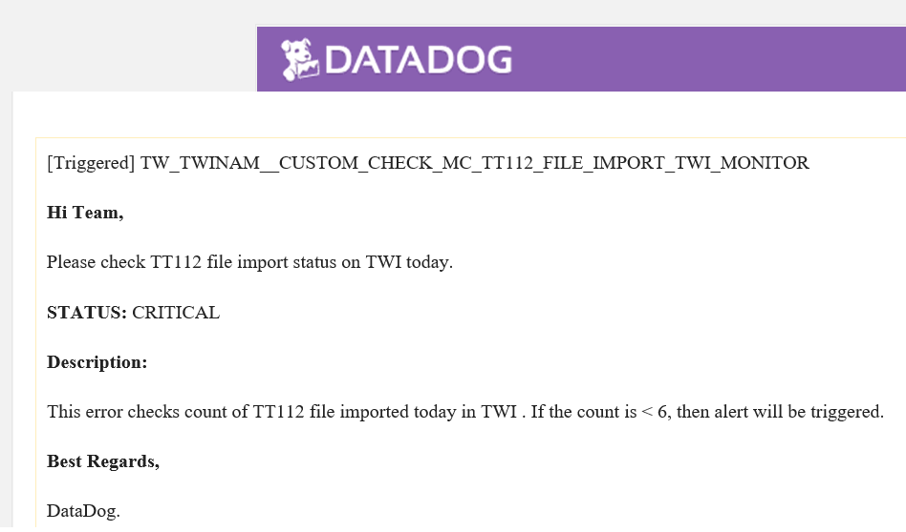

#### 4.4.4 CUSTOM_CHECK_TT112_FILE_IMP_REJECT_COUNT_MONITOR

This alert checks rejection of TT112 file import batch on TWI for the day. There is one field (reject message) in TWI batch table. This alert checks count on DB level. If the count is greater than 0, then alert will be triggered.

|  |
| --- |
| **MV NAME:** TWI.DD_MV_NAM_TT112_1240_IMP_FILES_REJECT_COUNT_TWI  **DB NAME:** CMSINAM – WP3  **Query:**  SELECT COUNT (*) MC_NAM_TT112_1240_IMP_FILES_REJECT_COUNT_TWI  FROM twi.batch  WHERE rejectmessage IS NOT NULL  AND TO_DATE (TO_CHAR (createdtime, 'DD-MON-YYYY'), 'DD-MON-YYYY') =  TO_DATE (TO_CHAR (SYSDATE - 1, 'DD-MON-YYYY'),  'DD-MON-YYYY')  AND filename LIKE 'TT112T0%'; |

**Alert Configuration:**

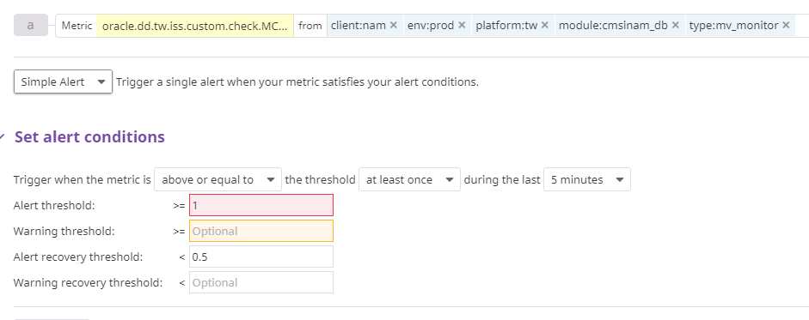

**Sample Email:**

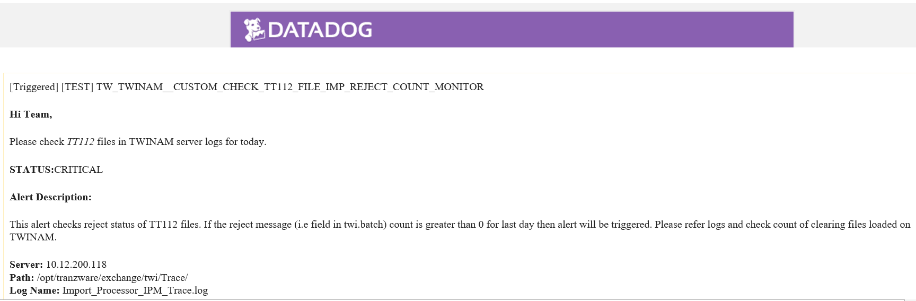

#### 4.4.5 CUSTOM_CHECK_EXTRACT_PCT_ERROR_MONITOR

This alert checks PCT error in extract batch in PCT module under batch operations. This alert checks count of errors at DB level. If the count is greater than 0, then alert will be triggered.

|  |
| --- |
| **MV NAME:** A4M.DD_MV_NAM_CHECK_EXTRACT_PCT_ERROR_COUNT_CMS  **DB NAME:** CMSINAM – WP3  **Query:**  SELECT COUNT (*) NAM_CHECK_EXTRACT_PCT_ERROR_COUNT_CMS  FROM textractpacket  WHERE description = 'TranzWare Online'  AND TO_DATE (TO_CHAR (createsysdate, 'DD-MON-YYYY'), 'DD-MON-YYYY') =  TO_DATE (TO_CHAR (SYSDATE, 'DD-MON-YYYY'), 'DD-MON-YYYY')  AND errcount <> 0  ORDER BY packno DESC; |

**Alert Configuration:**

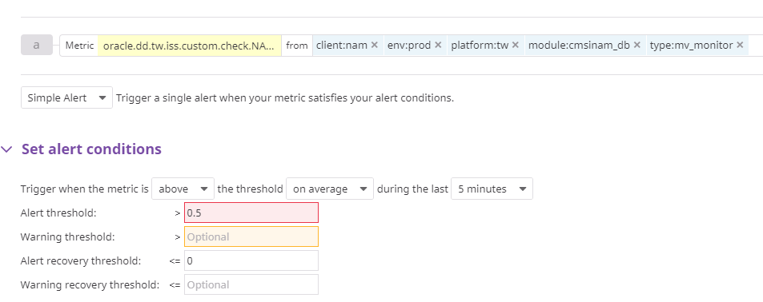

**Sample Email:**

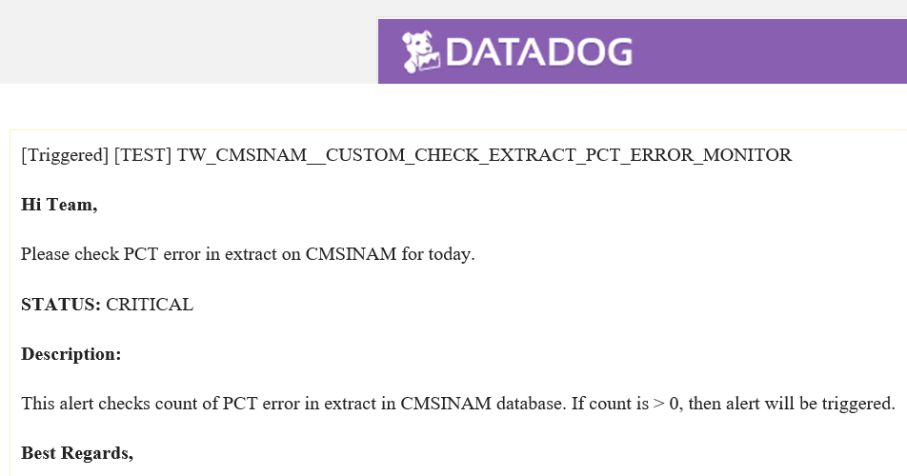

#### 4.4.6 CUSTOM_CHECK_MC_CLEARING_PCT_ERROR_MONITOR

This alert checks PCT error in MC clearing batch in PCT module under batch operations. This alert checks count of errors at DB level. If the count is greater than 0, then alert will be triggered.

|  |
| --- |
| **MV NAME:** A4M.DD_MV_NAM_CHECK_CLEARING_PCT_ERROR_COUNT_CMS  **DB NAME:** CMSINAM-WP3  **Query:**  SELECT COUNT (*) NAM_CHECK_CLEARING_PCT_ERROR_COUNT_CMS  FROM textractpacket  WHERE description = 'TranzWare Interchange'  AND TO_DATE (TO_CHAR (createsysdate, 'DD-MON-YYYY'), 'DD-MON-YYYY') =  TO_DATE (TO_CHAR (SYSDATE, 'DD-MON-YYYY'), 'DD-MON-YYYY')  AND errcount <> 0  ORDER BY packno DESC; |

**Alert Configuration:**

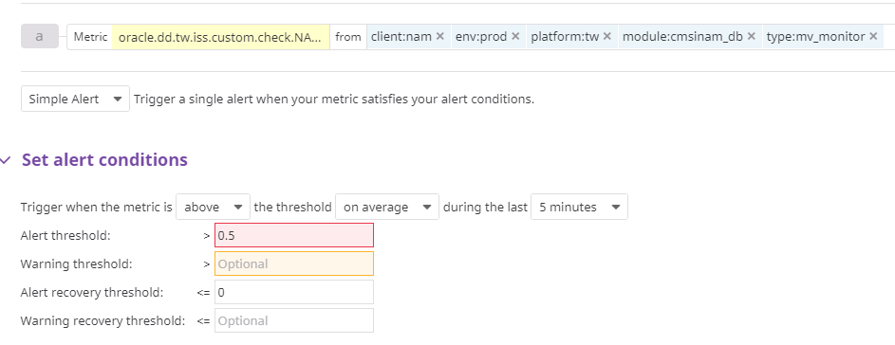

**Sample Email:**

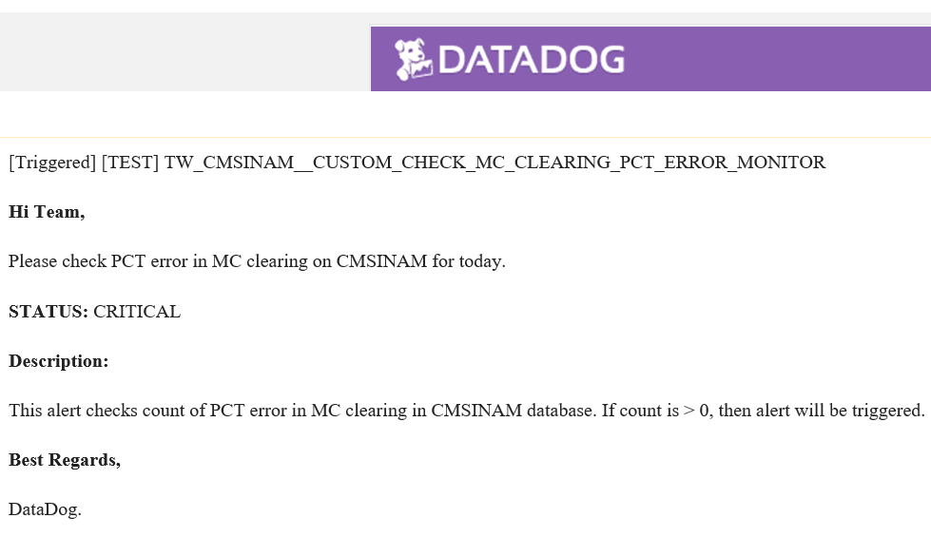

#### 4.4.7 CUSTOM_CHECK_EXTRACT_COMPARISON_MONITOR

For extract comparison, we have configured four alert for each batch (create_card, create_account, create_person, main_txn). It compares count of each batch between CMSINAM and TWONAM. If any of the count mismatch, then alert will be triggered for that batch type respectively.

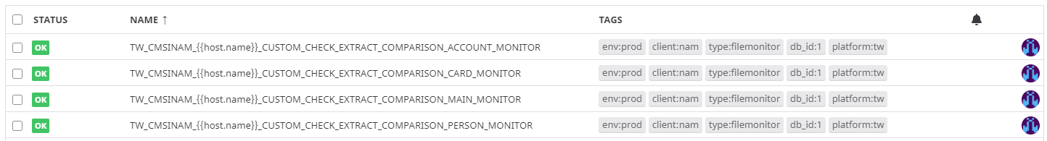

|  |
| --- |
| **MV NAME:** A4M.DD_MV_TWCMS_EXTRACT_COMPARISON_COUNTDB  **DB NAME:** CMSINAM-WP3  **Query:**  Select substr(a.key,1,9) as LAST_PACKNO_TWCMS , a.allcount , a.execcount, case when substr(a.key,44,4) = 'Main' then 'MAIN' when substr(a.key,44,3) = '336' then 'CREATE_CARD' when substr(a.key,44,3) = '525' then 'CREATE_ACCOUNT' when substr(a.key,44,4) = '1502' then 'CREATE_PERSON' else 'UNKNOWN' end as EXTRACT_TYPE from texpacket a where a.branch = 1050 and a.packtype = 1 and substr(a.key,11,4) = '3.42' and a.datecreate > (Select max(b.datecreate-1) from texpacket b where b.branch = 1050 and b.packtype = 2 and substr(b.key,46,12) = 'WDNI_to_TWO_') and substr(a.key,1,9)= (Select max (substr(b.key,1,9)) from texpacket b where b.branch = 1050 and b.packtype = 1 and substr(b.key,11,4) = '3.42' ) order by a.datecreate desc;  **MV NAME:** A4M.DD_MV_TWO_EXTRACT_COMPARISON_COUNTDB  NAME: TWONAM-WP3  **Query:**  Select CREATE_CARD.cnt CREATE_CARD,CREATE_ACCOUNT.cnt CREATE_ACCOUNT,CREATE_PERSON.cnt CREATE_PERSON,MAIN.cnt MAIN from ( Select count cnt from tla where trancode = 336 and respcode in (1,2,59) and packno = (Select max(packno) from tla_dir where status = 1 ) ) CREATE_CARD, ( Select count cnt from tla where trancode = 525 and respcode in (1,2,59) and packno = (Select max(packno) from tla_dir where status = 1 ) ) CREATE_ACCOUNT, ( Select count cnt from tla where trancode = 1502 and respcode in (1,2,59) and packno = (Select max(packno) from tla_dir where status = 1 ) ) CREATE_PERSON, ( Select count cnt from tla where respcode in (1,2,59) and packno = (Select max(packno) from tla_dir where status = 1 ) and trancode in ('10','15','20','22','23','26','27','28','29','30','31','40','42','43','48','50','52','53','54','55','56','57','58','60','61','62','63','64','65','66','67' ,'68','69','70','71','72','74','75','77','81','82','83','84','85','86','87','89','90','91','92','93','96','97','98','100','101','102','103','105','106','107','108','109', '110','111','112','113','114','115','116','117','118','121','122','123','124','125','126','127','128','129','130','131','132','133','134','137','138','139','140','141', '142','143','144','145','146','147','148','150','151','153','154','155','156','157','158','159','160','161','162','165','166','167','168','169','170','172','173','176', '177','178','179','180','181','182','183','185','187','188','189','190','193','195','196','197','198','199','201','202','205','206','301','302','303','304','305','306', '307','308','309','310','311','312','313','314','315','316','317','318','319','320','321','322','323','324','325','326','327','328','329','330','331','332','333','334', '335','337','338','339','340','341','342','343','345','347','348','349','350','351','352','353','354','355','356','357','358','359','360','361','362','363','364','365', '366','367','369','370','371','372','373','374','375','376','377','378','379','380','383','384','386','387','388','389','390','391','392','398','399','900', '1301','1302','1304','1305','1306','1307','1308','1309','1310','1311','1312','1313','1314','1315','1316','1317','1318','1319','1320','1321','1322','1323','1324','1325', '1326','1327','1328','1329','1330','1331','1332','1333','1334','1335','1336','1337','1338','1339','1340','1341','402','403','405','414','416','417','423','425','440', '442','443','444','446','447','448','449','450','460','467','472','473','486','487','504','506','507','508','509','510','512','514','515','516','517','522','527','528', '529','530','535','538','552','560','568','569','580','586','587','588','592','598','1504','1505','1506','1518','1529','1542','1551','1552','1553','1554','1555','1561', '1564','1565','1580','1596','1598','1599','2500','2501','2502','2514','2521','2526','2528','2530','2532','602','606','611','621','622','701','702','703','704','705','706', '707','708','709','710','711','712','713','714','715','716','717','718','719','720','721','722','723','724','725','751','752','753','754','756','757','758','759','799') ) MAIN |

**Sample Email:**

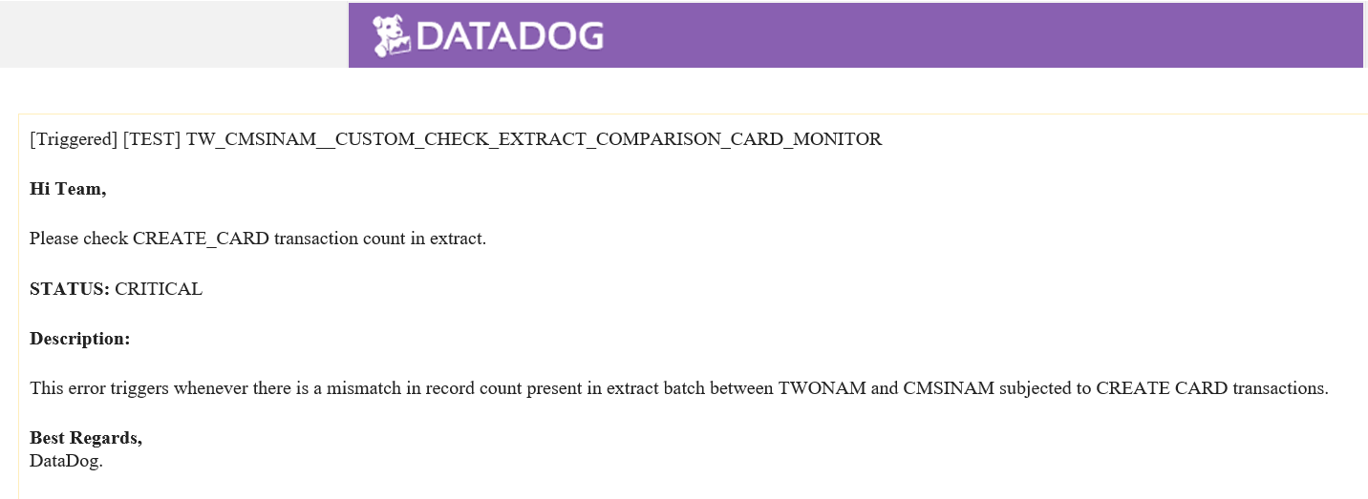

# NAM Dashboard:

## Application process monitor:

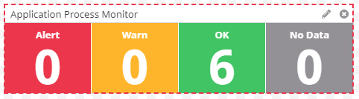

Under this widget, below alert have been configured.

* TWONAM FLORA_PROCESS_MONITOR
* ITPSRV_PROCESS_MONITOR
* PGS_PROCESS_MONITOR
* CPI2_PROCESS_MONITOR
* TWRBNAM_FLORA _PROCESS_MONITOR
* TW_TWONAM_NYCE_STUNNEL_PROCESS_MONITOR

All alert under this widget have been tagged as db_id:8

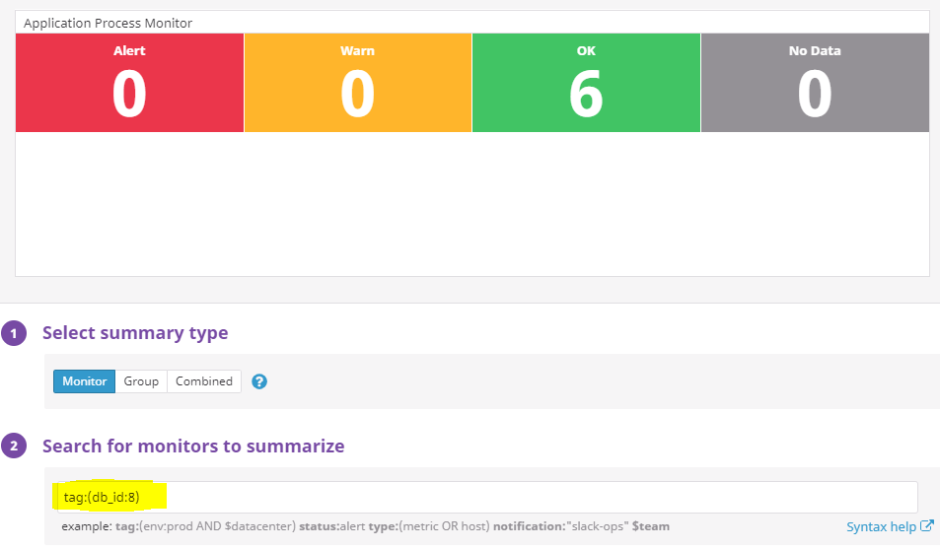

## 5.2 Log monitor:

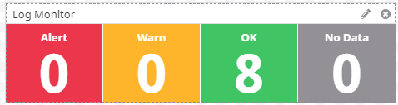

Under this widget, below alert have been configured.

* TW_TWINAM_CUSTOM_CHECK_LOGS_EXCEPTION_MONITOR
* TW_TWINAM_CUSTOM_CHECK_LOGS_ORA_MONITOR
* TW_TWONAM_CUSTOM_CHECK_ORA_STANDIN_AUTH_MONITOR
* TW_TWONAM_CUSTOM_CHECK_MC_CONNECTION_LOST_MONITOR
* TW_TWONAM_CUSTOM_CHECK_NYCE_CONNECTION_LOST_MONITOR
* TW_TWONAM_CUSTOM_CHECK_SMTP_EXCEPTION_MONITOR

All alert under this widget have been tagged as db_id:3.

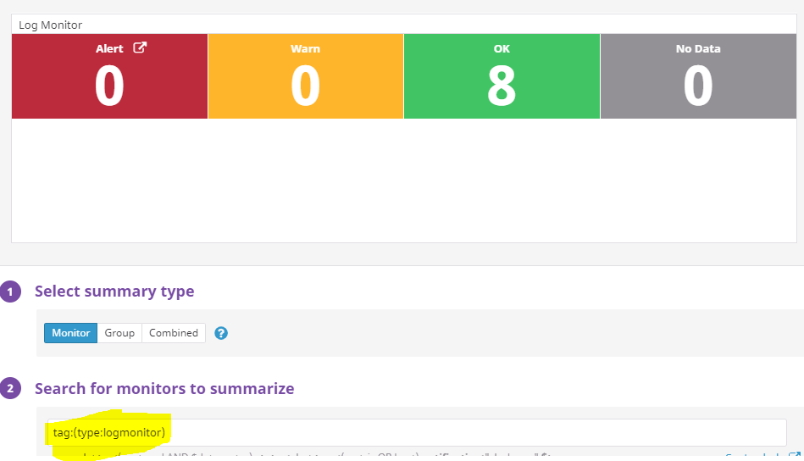

## 5.3 File monitor:

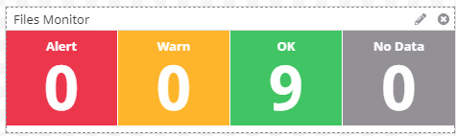

Under this widget, below alert have been configured.

* TW_CMSINAM_CUSTOM_CHECK_AUTH_REPORT_STAGE_MONITOR
* TW_CMSINAM_CUSTOM_CHECK_CLEAR_REPORT_STAGE_MONITOR
* TW_CMSINAM_CUSTOM_CHECK_SMS_CLEAR_REPORT_STAGE_MONITOR
* TW_CMSINAM_CUSTOM_CHECK_UNPOSTED_MC_STAGE_MONITOR
* TW_CMSINAM_CUSTOM_CHECK_UNPOSTED_VISA_STAGE_MONITOR
* TW_CMSINAM_CUSTOM_CHECK_EXTRACT_CREATE_ACCOUNT_MONITOR
* TW_CMSINAM_CUSTOM_CHECK_EXTRACT_CREATE_CARD_MONITOR
* TW_CMSINAM_CUSTOM_CHECK_EXTRACT_CREATE_PERSON_MONITOR
* TW_CMSINAM_CUSTOM_CHECK_EXTRACT_CREATE_MAIN_MONITOR

All alert under this widget have been tagged as db_id:2

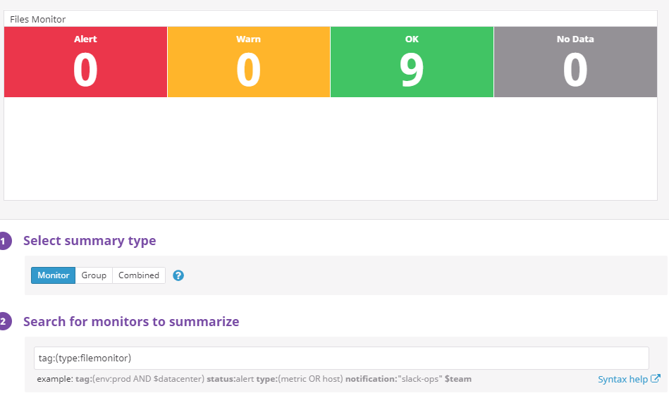

## 5.4 BAU TASK Monitor

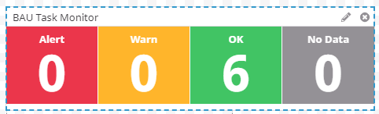

Under this widget, below alert have been configured.

* CUSTOM_CHECK_MC_OAS_FILE_EXPORT_TWI_MONITOR
* CUSTOM_CHECK_MC_TIP_FILE_EXPORT_TWI_MONITOR
* CUSTOM_CHECK_MC_TT112_FILE_IMPORT_TWI_MONITOR
* CUSTOM_CHECK_TT112_FILE_IMP_REJECT_COUNT_MONITOR
* CUSTOM_CHECK_EXTRACT_PCT_ERROR_MONITOR
* CUSTOM_CHECK_MC_CLEARING_PCT_ERROR_MONITOR

All alert under this widget have been tagged as db_id:7

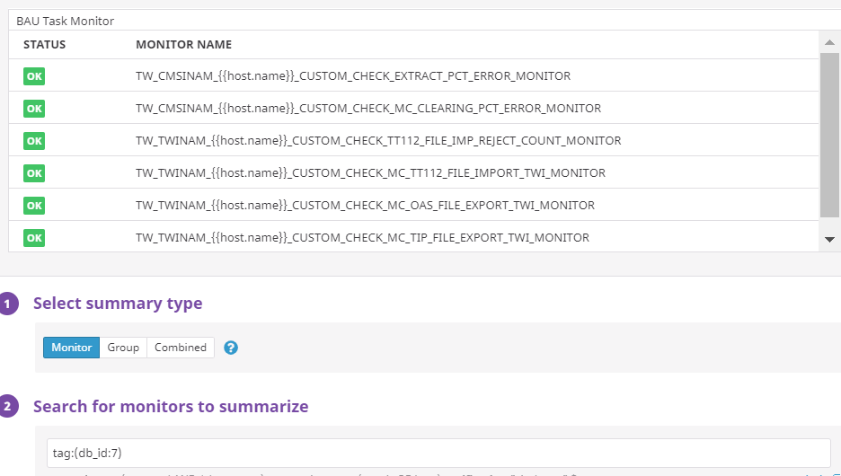

## 5.5 NAM CARD STATS

This widget is just a monitor and there is no alert held with these stats. It is configured to show stats subjected to active, closed and not active stat fetching through CMSINAM DB and new card request count is by TWONAM DB (i.e trancode) for last day.

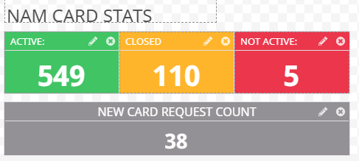

|  |
| --- |
| **MV NAME:** A4M.DD_MV_CARD_COUNT_BY_STATUS_CMS  **DB NAME:** CMSINAM– WP3  **Query:**  SELECT  CASE WHEN b.crd_stat IN ('1', 'C') THEN 'ACTIVE'  WHEN b.crd_stat IN ('9','8','F','2','3') THEN 'CLOSED'  ELSE 'NOT ACTIVE' END CARD_STATUS, COUNT (*)  FROM a4m.tcard a INNER JOIN a4m.TREFERENCECRD_STAT b ON a.crd_stat = b.crd_stat  GROUP BY  CASE WHEN b.crd_stat IN ('1', 'C') THEN 'ACTIVE'  WHEN b.crd_stat IN ('9','8','F','2','3') THEN 'CLOSED'  ELSE 'NOT ACTIVE' END  **MV NAME:** BAOBAB.DD_MV_NEW_CARD_REQ_COUNT_TODAY  **DB NAME:** TWONAM– WP3  **Query:**  SELECT COUNT (*) NEW_CARD_COUNT  FROM tlg WHERE trancode = '336'  AND respcode = 1 AND  TO_DATE (TO_CHAR (time, 'DD-MON-YYYY'), 'DD-MON-YYYY') =  TO_DATE (TO_CHAR (SYSDATE - 1, 'DD-MON-YYYY'),'DD-MON-YYYY'); |

## 5.6 UNIT STATE MONITOR

This widget is configure to show unit states. Datadog fetching metric values by calling FIMI API (GetUnitState). For this monitoring a separate terminal, port and unit has been created on TWONAM application. There are 3 states for each unit is monitoring (i.e started, connected and signon (for MasterCard only)). Datadog agent is initiating a FIMI xml call through python script and in return TWONAM is sending state of that particular unit. For more understanding of alert, please review script present on TWO application server on path (/etc/Datadog/check.d/Custom_Check_Unit_State.py).

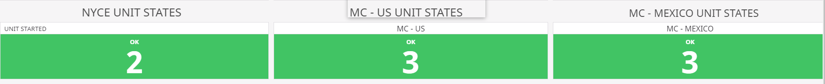

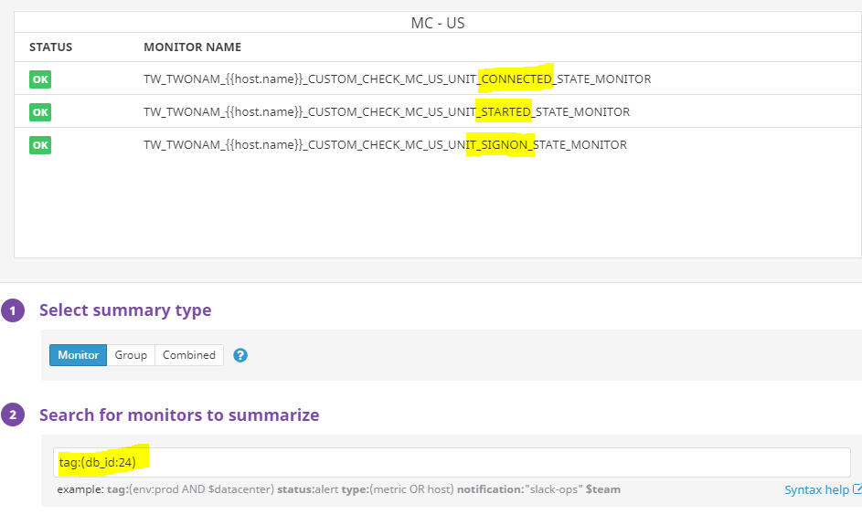

## 5.7 NYCE TRAFFIC

We have segregated NYCE traffic between MTI (0800 – echo messages) and MTI (0100, 0200 and 0220). This is real time monitoring through application logs. Please refer python script (/etc/Datadog/check.d/Custom_Check_NYCE_Traffic.py)

Under (MTI-0800) widget, traffic segregated between TWO instances that means Datadog is showing sum of all echo message received for last 5 minutes in each instance. Currently on each TWO instance, there are 2 NYCE units. Each metric contains sum of echo message received on both NYCE units in each instance for last 5 minutes.

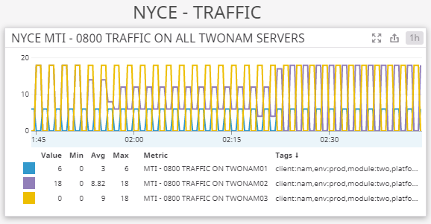

Under (MTI 0100, 0200 and 0220) widget, we have segregated traffic based on MTI type that means sum of MTI-100 received in all

NYCE units across TWONAM instances.

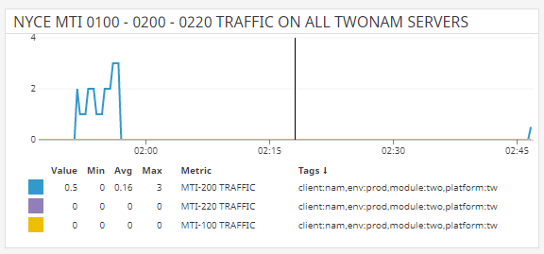

## 5.8 MC – UNITED STATES

We have segregated MC-US traffic between MTI (0800 – echo messages) and MTI (0100, 0200 and 0220). This is real time monitoring through application logs. Please refer python script (/etc/Datadog/check.d/Custom_Check_MC_US_Traffic.py units in each instance for last 5 minutes.

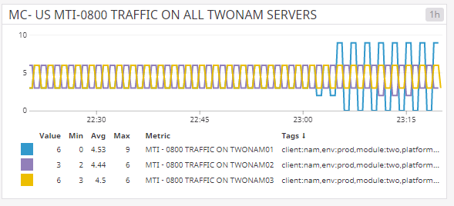

Under (MTI 0100, 0420 and 0120) widget, we have segregated traffic based on MTI type that means sum of MTI-100 received in all

MC-US units across TWONAM instances.

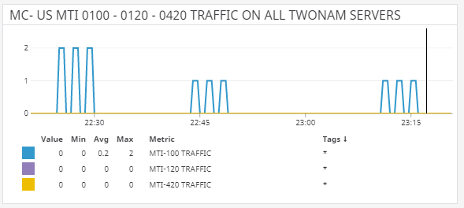

## 5.9 MC – MEXICO

We have segregated MC-MEX traffic between MTI (0800 – echo messages) and MTI (0100, 0200 and 0220). This is real time monitoring through application logs. Please refer python script (/etc/Datadog/check.d/Custom_Check_MC_MEX.py)

Under (MTI-0800) widget, traffic segregated between TWO instances that means Datadog is showing sum of all echo message received for last 5 minutes in each instance. Currently on each TWO instance, there are two MC-MEX units. This monitor takes count of string “inp >> 810” received in last 5 minutes. Each metric contains sum of total echo message received on all MC-MEX units in each instance for last 5 minutes.

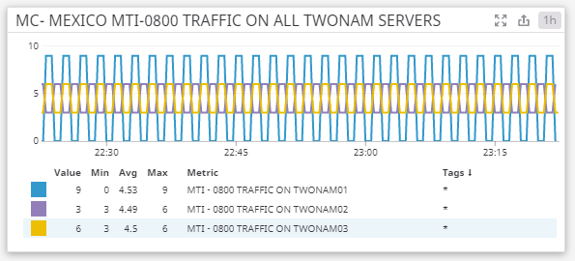

Under (MTI 0100, 0420 and 0120) widget, we have segregated traffic based on MTI type that means sum of MTI-100 received in all

MC-MEX units across TWONAM instances.

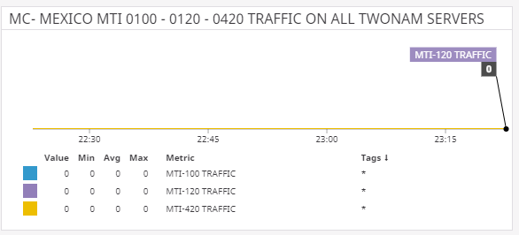

## 5.10 FIMI TRAFFIC

This widget show sum of request received on FIMI units. It is taking count of “Receive request from client” across all units in each instance in last 5 minutes. For more understanding, please refer /etc/Datadog/check.d/Custom_Check_FIMI_Traffic.py script. Currently there is no such traffic; however, it will be very useful to analyze the load on FIMI units.

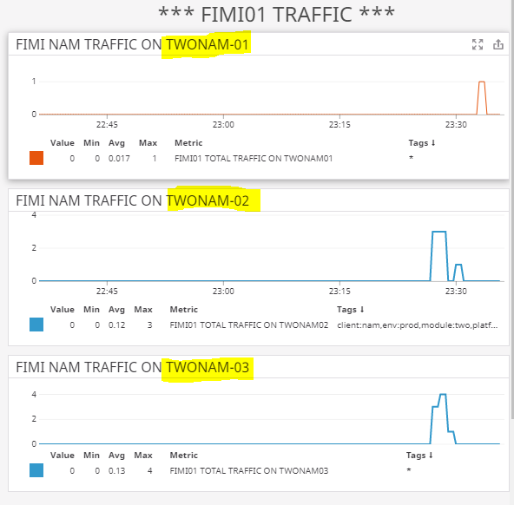

## 5.11 TODAYS COUNT:

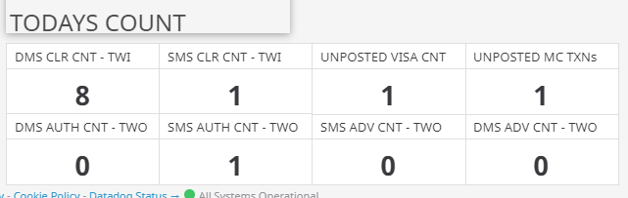

**Figure 5.11**

#### 5.11.1 SMS CLR CNT – TWI:

This shows total DMS (0200) transaction received in back office for last day (sysdate-1). This count must be matched with the SMS clearing report stage to client for the day (sysdate) around 11:15 am.

|  |
| --- |
| **MV:** A4m.DD_MV_NAM_SMS_TXN_FOR_LAST_DAY_COUNT_TWCMS  **DB NAME:** CMSINAM  **QUERY:**  SELECT COUNT (*) SMS_TXN_FOR_LAST_DAY_COUNT FROM a4m.ttlg WHERE TYPE = 200 AND TO_DATE (TO_CHAR (time, 'DD-MON-YYYY'), 'DD-MON-YYYY') = TO_DATE (TO_CHAR (SYSDATE - 1, 'DD-MON-YYYY'), 'DD-MON-YYYY'); |

#### 5.11.2 DMS CLR CNT – TWI:

This shows total clearing (type 1240) transaction received and imports in TWI between 03:10 am (sysdate-1) to 03:10 am (sysdate). This count must be matched with the clearing report stage to client for the day (sysdate) around 11:15 am.

|  |
| --- |
| **MV:** TWI.DD_MV_NAM_TT112_1240_IMP_COUNT_TWI  **DB NAME:** CMSINAM  **QUERY:**  SELECT COUNT (*) MC_NAM_TT112_1240_IMP_COUNT_TWI FROM twi.tran WHERE impbatchid IN ( SELECT id FROM twi.batch WHERE createdtime BETWEEN TO_DATE ( TO_CHAR ( TRUNC (SYSDATE - 1) + 0.132, 'DD-MON-RR HH24MISS'), 'DD-MON-RR HH24MISS') AND TO_DATE ( TO_CHAR ( TRUNC (SYSDATE) + 0.132, 'DD-MON-RR HH24MISS'), 'DD-MON-RR HH24MISS') AND filename LIKE 'TT112T0%' ) AND trantype = 1240; |

#### 5.11.3 UNPOSTED VISA CNT:

This shows number of records posted in wdccp_unposted_trx_Visa_YYYYMMMDD.csv.done. Please be noted that actual count for the report will reflect after 11:15 am and before the said timing, it will be showing previous day record count in report. Please refer /etc/Datadog/check.d/Custom_Check_Report_Row_Count.py

#### 5.11.4 UNPOSTED MC CNT:

This shows number of records posted in wdccp_unposted_trx_MC_YYYYMMMDD.csv.done. Please be noted that actual count for the report will reflect after 11:15 am and before the said timing, it will be showing previous day record count in report. Please refer /etc/Datadog/check.d/Custom_Check_Report_Row_Count.py.

#### 5.11.5 DMS AUTH CNT – TWO:

This shows type (0100) transactions received for a day. Refer figure 5.11.

#### 5.11.6 SMS AUTH CNT – TWO:

This shows type (0200) transactions received for a day. Refer figure 5.11.

#### 5.11.7 SMS ADV CNT – TWO:

This shows type (0220) transactions received for a day. Refer figure 5.11.

#### 5.11.8 DMS ADV CNT – TWO:

This shows type (0120) transactions received for a day. Refer figure 5.11.

|  |
| --- |
| **MV:** BAOBAB.DD_MV_TXN_COUNT_TODAY  **DB NAME:** TWONAM  **QUERY:**  SELECT fimi.cnt, dms.cnt DMS_CNT, sms.cnt SMS_CNT, dms_adv.cnt dms_adv, sms_adv.cnt sms_adv, total.cnt total_CNT FROM ( SELECT COUNT (*) cnt FROM tlg WHERE TYPE = 100 AND TO_DATE (TO_CHAR (time, 'DD-MON-YYYY'), 'DD-MON-YYYY') = TO_DATE (TO_CHAR (SYSDATE, 'DD-MON-YYYY'), 'DD-MON-YYYY') ) **DMS**,  ( SELECT COUNT (*) cnt FROM tlg WHERE TYPE = 200 AND TO_DATE (TO_CHAR (time, 'DD-MON-YYYY'), 'DD-MON-YYYY') = TO_DATE (TO_CHAR (SYSDATE, 'DD-MON-YYYY'), 'DD-MON-YYYY') ) **SMS**,  ( SELECT CASE WHEN COUNT (*) = 0 THEN 1 ELSE COUNT (*) END cnt FROM tlg WHERE TO_DATE (TO_CHAR (time, 'DD-MON-YYYY'), 'DD-MON-YYYY') = TO_DATE (TO_CHAR (SYSDATE, 'DD-MON-YYYY'), 'DD-MON-YYYY') ) **TOTAL**,  ( SELECT COUNT (*) cnt FROM tlg WHERE TYPE = 120 AND TO_DATE (TO_CHAR (time, 'DD-MON-YYYY'), 'DD-MON-YYYY') = TO_DATE (TO_CHAR (SYSDATE, 'DD-MON-YYYY'), 'DD-MON-YYYY') ) **DMS_ADV**,  ( SELECT COUNT (*) cnt FROM tlg WHERE TYPE = 220 AND TO_DATE (TO_CHAR (time, 'DD-MON-YYYY'), 'DD-MON-YYYY') = TO_DATE (TO_CHAR (SYSDATE, 'DD-MON-YYYY'), 'DD-MON-YYYY') ) **SMS_ADV**,  ( SELECT COUNT (*) cnt FROM tlg WHERE TYPE = 999 AND TO_DATE (TO_CHAR (time, 'DD-MON-YYYY'), 'DD-MON-YYYY') = TO_DATE (TO_CHAR (SYSDATE, 'DD-MON-YYYY'), 'DD-MON-YYYY') ) **FIMI**; |

# Slack:

We have also achieved the Datadog to Slack integration and a separate channel is created for datadog alerts, ideally, members from all relevant teams should be part of this channel to receive and respond to alerts, so all of you please join:

|  |  |  |
| --- | --- | --- |
| *Workspace* | *Channel Name* | *Channel Link* |
| wd-issuing | tw_dd_alerts | https://join.slack.com/share/zt-ehgvhi3o-myY~3AqyTpwpSgyMmFEG_Q |